**ssA MAJOR PROJECT REPORT**

**ON**

**AN ANALYTICAL STUDY ON THE PHISICO-CHEMICAL CHARACTERISTICS OF GROUND WATER IN VIJAYAWADA BY USING GIS AND ITS SUITABILITY**

*Submitted in partial fulfilment of the requirement for the award of the Degree in*

**BACHELOR OF TECHNOLOGY**

**IN**

**CIVIL ENGINEERING**

*Submitted by*

|  |  |  |
| --- | --- | --- |
| **L. SRINIVASA RAO** | **-** | **18501A0127** |
| **K. SAI ANAND VARDHAN** | **-** | **18501A0125** |
| **L.V.S.S. KISHORE** | **-** | **18501A0128** |
| **K. CHANDRASEKHAR** | **-** | **18501A0123** |

Under the Guidance of

**Dr. A. ADILAKSHMI**,

Professor



**DEPARTMENT OF CIVIL ENGINEERING**

**PRASAD V. POTLURI SIDDHARTHA INSTITUTE OF TECHNOLOGY (AUTONOMOUS)**

**Affiliated to JNTU Kakinada, Approved by AICTE, New Delhi**

**Accredited by NBA & NAAC A+, ISO 9001:2015 Certified Institution**

**KANURU, VIJAYAWADA-520007**

**2021-2022**

**PRASAD V. POTLURI SIDDHARTHA INSTITUTE OF TECHNOLOGY**

**(Autonomous)**

**DEPARTMENT OF CIVIL ENGINEERING**

**KANURU, VIJAYAWADA – 520007.**



**CERTIFICATE**

This is to certify that the Project work entitled **“AN ANALYTICAL STUDY ON THE PHISICO-CHEMICAL CHARACTERISTICS OF GROUND WATER IN VIJAYAWADA BY USING GIS AND ITS SUITABILITY”** is a record of bonafide work carried out by **L. SRINIVASA RAO (18501A0127), K. SAI ANAND VARDHAN (18501A0125), L.V.S.S. KISHORE (18501A0128), K. CHANDRASEKHAR (18501A0123),** for the award of **BACHELOR OF TECHNOLOGY** degree in **CIVIL ENGINEERING** at **PRASAD V. POTLURI SIDDHARTHA INSTITUTE OF TECHNOLOGY** is a record of student’s work carried out under our supervision and guidance during academic year 2021 – 2022.

**(Dr. A. ADILAKSHMI) (Dr. K. RAMESH)**

**Project Guide Head of the Department**

**External Examiner Internal Examiner**

**DECLARATION**

This is to certify that the Major project report entitled **“AN ANALYTICAL STUDY ON THE PHISICO-CHEMICAL CHARACTERISTICS OF GROUND WATER IN VIJAYAWADA BY USING GIS AND ITS SUITABILITY”** written and submitted by us is an original work done under the guidance of **Dr. A. ADILAKSHMI, Professor** is submitted in partial fulfillment of the requirements for the award of the Degree of Bachelor of Technology in Civil Engineering. This is a record of bonafide work carried out by us and the results embodied in this Project Report have not been reproduced and copied from any source.

**PROJECT ASSOCIATES:**

|  |  |  |
| --- | --- | --- |
| **L. SRINIVASA RAO** | **-** | **18501A0127** |
| **K. SAI ANAND VARDHAN** | **-** | **18501A0125** |
| **L.V.S.S. KISHORE** | **-** | **18501A0128** |
| **K. CHANDRASEKHAR** | **-** | **18501A0123** |

**ACKNOWLEDGEMENT**

The satisfaction and euphoria on the successful completion of any task would be incomplete without the mention of the people who made it possible, whose constant guidance and encouragement crowned our effort with success.

We would like to express our profound appreciation to our Principal Dr. **K. Sivaji Babu, Principal, PVP Siddhartha Institute of Technology** for extending his official support for the completion of our Major Project.

We express our thanks to **Dr. K. Ramesh, Head of Civil Engineering Department**, for all the facilities provided to successfully complete our Major project work.

We are deeply indebted to our Project Guide, **Dr. A. Adilakshmi**, **Professor** for the motivation, guidance and patience throughout this Major project work. We appreciate her broad range of expertise and attention to detail, as well as the constant encouragement she has given to us over the years.

In our association with all the above persons, we experienced not only their depth of knowledge but also affection towards us. Finally, we take this opportunity to thank one and all of our **Civil Engineering Teaching & Non - Teaching Staff** for their able cooperation both academic and non – academic all throughout our four years. We shall remember all our staff as long as our memory lives.

**PROJECT ASSOCIATES:**

|  |  |  |
| --- | --- | --- |
| **L. SRINIVASA RAO** | **-** | **18501A0127** |
| **K. SAI ANAND VARDHAN** | **-** | **18501A0125** |
| **L.V.S.S. KISHORE** | **-** | **18501A0128** |
| **K. CHANDRASEKHAR** | **-** | **18501A0123** |

**ABSTRACT**

The present study on the assessment of Ground water quality which is carried out in several locations in Vijayawada, Andhra Pradesh. The Ground water quality study was assessed and considerable amount of data was generated between various parameters and projected by using ArcGIS 10.8.1 version software. Maps of ground water prospects zones are prepared from the toposheets, serves as efficient tools for detailed surface based hydrogeological survey.

Arc-GIS software is used to give an insight of the integrity of ground water in Vijayawada. This assessment will help in order to develop good ground water quality region successfully. Environmental changes taking place in the Ground water should be recorded with the help of GIS and Satellite based image maps should be used as basic input parameters for Environmental mapping and recording of ground water environment. Indiscriminate use of fertilizers in certain areas has resulted in very high concentrations of some of the chemical constituents in groundwater.

**TABLE OF CONTENTS**

**CHAPTER 1: INTRODUCTION** 2

1.1 General 2

1.2 Indian Scenario 4

1.3 Pollution 4

1.4 Study Area 4

1.4.2 Geography 5

1.4.2 Demographics 6

1.5 Scope of the Study 7

1.5.1 Need for the Study 7

1.5.2 Objectives 7

1.6 GIS: 7

1.6.1 Components of GIS 8

1.6.2 Data Structures 9

1.6.3 Spatial Database Creation 9

1.6.4 Attribute Database Creation 10

1.7 Maps 10

1.7.1 Base Map: 10

**CHAPTER 2: LITERATURE REVIEW** 13

**CHAPTER 3: METHODOLOGY** 17

3.1 Study Area Selection 18

3.2 Sample Collection 19

3.2.1 Collection of water samples at different locations 20

**CHAPTER 4: ANALYSIS OF WATER SAMPLES** 22

4.1 Parametric Analysis 22

4.1.1 Chemical Tests……..……………………………………………………………..22

4.1.2 Physical Tests 22

4.2 Experimental Procedures 24

4.2.1 Determination of pH 24

4.2.2 Determination of Turbidity 25

4.2.3 Determination of Alkalinity 26

4.2.4 Determination of Electric Conductivity 27

4.2.5 Determination of Total Solids,Total Suspended Solids & Total Dissolved Solids 28

4.2.6 Determination of Chloride Content 30

4.2.7 Determination of Total Hardness 31

4.2.8 Determination of Permanent and Temporary Hardness 32

4.2.9 Determination of Calcium and Magnesium 33

4.2.10 Determination of Sulphate 34

4.3 Testing of Water Samples in Laboratory..………………………..….35

4.4 Test Results 36

4.4.1 Location 1: Patamata 36

4.4.2 Location 2: Gandhi Nagar 37

4.4.3 Location 3: Machavaram 38

4.4.4 Location 4: Nidamanuru 39

4.4.5 Location 5: Labbipet 40

4.4.6 Location 6: Moghalrajpuram 41

4.4.7 Location 7: Gunadala 42

4.4.8 Location 8: Krishna Lanka 43

4.4.9 Location 9: Auto Nagar 44

4.4.10 Location 10: Patamatalanka 45

4.4.11 Location 11: Governorpet 46

4.4.12 Location 12: Enikepadu 47

4.4.13 Location 13: Kanuru 48

4.4.14 Location 14: Ramavarappadu 49

4.4.15 Location 15: Gollapudi 50

4.4.16 Location 16: Ayodhya Nagar 51

4.9 Thematic Maps showing Spatial Distribution of Sample Analysis 52

CHAPTER 5: RESULTS AND DISCUSSION 58

5.1 Insight……...………………………………………………………….…………….….60

5.1.2 Turbidity 60

5.1.3 Alkalinity 60

5.1.4 Cunductivity 60

5.1.5 TDS 60

5.1.6 Chloride 60

5.1.7 Calcium 60

5.1.8 Magnesium 60

5.1.9 Sulphate 61

5.2 Effects and Remedies of unsafe parameters……………………………………….61

CONCLUSION 66

REFERENCES 67

**LIST OF FIGURES**

|  |  |  |
| --- | --- | --- |
| **Figure No.** | **Caption** | **Page No.** |
| 1.1 | Location of Vijayawada | 5 |
| 1.2 | Map of Vijayawada | 6 |
| 1.3 | Vijayawada Toposheet/Base Map | 11 |
| 3.1 | Sample locations on Thematic Map | 19 |
| 4.1 | Patamata | 36 |
| 4.2 | Gandhi Nagar | 37 |
| 4.3 | Machavaram | 38 |
| 4.4 | Nidamanuru | 39 |
| 4.5 | Labbipet | 40 |
| 4.6 | Moghalrajpuram | 41 |
| 4.7 | Gundala | 42 |
| 4.8 | Krishna Lanka | 43 |
| 4.9 | Auto Nagar | 44 |
| 4.10 | Patamatalanka | 45 |
| 4.11 | Governorpet | 46 |
| 4.12 | Enikepadu | 47 |
| 4.13 | Kanuru | 48 |
| 4.14 | Ramavarappadu | 49 |
| 4.15 | Gollapudi | 50 |
| 4.16 | Ayodhya Nagar | 51 |
| 4.17 | Spatial Distribution of pH | 52 |
| 4.18 | Spatial Distribution of Alkalinity | 52 |
| 4.19 | SpatialDistribution of Turbidity | 53 |
| 4.20 | Spatial Distribution of Conductivity | 53 |
| 4.21 | Spatial Distribution of TDS | 54 |
| 4.22 | Spatial Distribution of Chloride | 54 |
| 4.23 | Spatial Distribution of Total Hardness | 55 |
| 4.24 | Spatial Distribution of Calcium | 55 |
| 4.25 | Spatial Distribution of Magnesium | 56 |
| 4.26 | Spatial Distribution of Sulphate | 56 |

**LIST OF TABLES**

|  |  |  |
| --- | --- | --- |
| **Table No.** | **Caption** | **Page No.** |
| 1.1 | Attribute notations | 10 |
| 3.1 | Details of Sampling Location and Coordinates | 18 |
| 4.1 | Chemical Tests | 22 |
| 4.2 | Physical Tests | 23 |
| 4.3 | Test Results of Patamata | 36 |
| 4.4 | Test Results of Gandhi Nagar | 37 |
| 4.5 | Test Results of Machavaram | 38 |
| 4.6 | Test Results of Nidamanuru | 39 |
| 4.7 | Test Results of Labbipet | 40 |
| 4.8 | Test Results of Moghalrajpuram | 41 |
| 4.9 | Test Results of Gunadala | 42 |
| 4.10 | Test Results of Krishna Lanka | 43 |
| 4.11 | Test Results of Auto Nagar | 44 |
| 4.12 | Test Results of Patamatalanka | 45 |
| 4.13 | Test Results of Governorpet | 46 |
| 4.14 | Test Results of Enikepadu | 47 |
| 4.15 | Test Results of Kanuru | 48 |
| 4.16 | Test Results of Ramavarappadu | 49 |
| 4.17 | Test Results of Gollapudi | 50 |
| 4.18 | Test Results of Ayodhya Nagar | 51 |
| 5.1 | Water Quality Standards | 58 |
| 5.2 | Evaluated Water Quality Parameters at different locations | 59 |

**CHAPTER 1**

**INTRODUCTION**

**CHAPTER 1**

**INTRODUCTION**

* 1. **General:**

Water is the precious gift of nature to human beings. By assessing the physical, chemical, and biological characteristics of water, we can conclude its quality. The main sources of water for domestic and drinking purposes are surface water and groundwater

It is sometimes thought that water flows through underground rivers or that it collects in underground lakes. Groundwater is not confined to only a few channels or depressions in the same way that surface water is concentrated in streams and lakes. Rather, it exists almost everywhere underground. It is found underground in the spaces between particles of rock and soil, or in crevices and cracks in rock.

The water filling these openings is usually within 100meters of the surface. Much of the earth's fresh water is found in these spaces. At greater depths, because of the weight of overlying rock, these openings are much smaller, and therefore hold considerably smaller quantities of water.

Groundwater flows slowly through water-bearing formations (aquifers) at different rates. In some places, where groundwater has dissolved limestone to form caverns and large openings, its rate of flow can be relatively fast but this is exceptional.

Many terms are used to describe the nature and extent of the groundwater resource. The level below which all the spaces are filled with water is called the water table. Above the water table lies the unsaturated zone. Here the spaces in the rock and soil contain both air and water. Water in this zone is called soil moisture. The entire region below the water table is called the saturated zone, and water in this saturated zone is called Groundwater.

Groundwater is the source of about 90% of the country’s drinking water. In rural areas, almost all the water supply comes from groundwater and more than one-third of our 100 largest cities depend on it for at least part of their supply. Historically, groundwater has been considered to be safe to drink.

However, of late groundwater is becoming contaminated with industrial effluents discharged on land and septic systems, as well as illegal and uncontrolled hazardous waste sites are involved in contaminating the ground water. Once contaminated it is difficult if not impossible to restore the groundwater.

The total quantity of groundwater on Earth is estimated as more than 50 million cu.km of this, 4 million cu.km. are considered as a reasonable quantity of fresh water, that could be exploited, which excludes water that will not drain from small pore spaces, saline water and water lying deep in confined aquifers.

The total groundwater reserves of India up to a depth of 300 meters are estimated to be at 3,700 million-hectare meters (Mha-m) and the usable groundwater at around 42 Mha-m, per year. Out of this, 27.37% is exploited. The state of Andhra Pradesh has a usable potential of 2.21mham/y.

In addition, ground water supplies are being stressed by increasing demand for water as the world’s population continues to grow and communities seek short-term solutions to this rising demand. As demand for potable water increases and as supplies decrease, ground water may be relied upon more heavily as a source. Consequently, the availability of ground water now and in the future will be important; overuse of ground water may result in serious shortages in many areas, especially in water-scarce regions.

With the ever-increasing pressure of human population, there is severe stress on water resources. It is becoming scarce in rural as well as urban areas mainly due to reduction in infiltration rate as a result of deforestation in rural areas and large-scale paving of the surface in urban area. In India, though a huge quantity of surface water is available, the topography and other factors limit the storage of this water. Where the surface water is scarce, ground water assumes importance in the context of water supply as an alternative source. Due to over-exploitation of ground water in many areas the ground water levels show a declining trend, which in turn tends to increase both the investment cost and the operational cost.

Ground water acts as a reservoir by virtue of large pore space in earth materials. It also acts as a conduit, which can transport water over long distances, and as a mechanical filter, which improves water quality by removing suspended solids and bacterial contamination forming main source for rural domestic use.

It is replenished or recharged by precipitation through rain, snow sleet and hail. In some areas of the world, people face serious water shortage because groundwater is used faster than it is naturally replenished. In other areas groundwater is polluted by human activities.

* 1. **Indian Scenario:**

In India, there is severe stress on water resources with the ever-increasing human population. The population in India is increasing at an annual rate of 1.7crores and by the year 2050 it is said that it may cross 150crores. In India, out of an annual rainfall of 4000 billion cubic meters in an area of 329 million hectares, 41 % (10,02,04 million) is retained as soil moisture and 9% (2,19,96 million) seeps in for recharging groundwater. Of the 40 % stream flow water, 8 % is used for irrigation, 2 % for domestic use, 4 % for industries, and about 12% for electricity generation.

India will be requiring about 1,2010,00 million cubic meters of water in the year 2050 A.D. to cater to the needs of about 150 crores population for food production, drinking water, domestic, industrial, navigational, environmental and ecological requirements due to which there is a great need to conserve water.

* 1. **Pollution:**

Groundwater has been used everywhere in the world for a long time because of its easy accessibility and good quality. In urban areas, groundwater as a source of domestic, commercial and industrial water has greatly contributed to the development of cities. Groundwater in urban areas is sometimes contaminated with multiple contaminants at higher concentrations than in rural areas. For example, one of the most prevalent contaminants in urban groundwater, nitrate, is commonly the product of agricultural runoff due to the use of fertilizers in rural areas. In urban areas, however, fertilizers in agricultural fields are rather minor sources, but leaky sewage, septic tanks, industrial spillages, landfill leachates, and fertilizers used in gardens and parks are other, more common sources of nitrate. Those sources of nitrate can also become sources of other hazardous substances or health-related microorganisms. Other than nitrogen, there are many contaminants in urban groundwater including arsenic, fluoride, heavy metals, and volatile organic carbons. Several kinds of pharmaceuticals, N-nitroso dimethylamine (NDMA), and per fluorinated surfactants (PFSs) can also be detected in urban groundwaters.

* 1. **Study Area:**

The city of VIJAYAWADA is situated at Latitude 16°31′8.50″N & Longitude 80°37′17.38″E with an area of 61.88 km2. Vijayawada (formerly Bezawada) is the second largest city in the Indian state of Andhra Pradesh and is a part of the state's capital region, Amaravati Capital Region. It is the administrative headquarters of the NTR district. Vijayawada lies on the banks of Krishna River surrounded by the hills of Eastern Ghats, known as Indrakeeladri Hills. It geographically lies on the center spot of Andhra Pradesh.[10] The city has been described as the commercial, political, cultural and educational capital of Andhra Pradesh, second largest city in Andhra Pradesh and is one of the fastest growing urban areas in India.

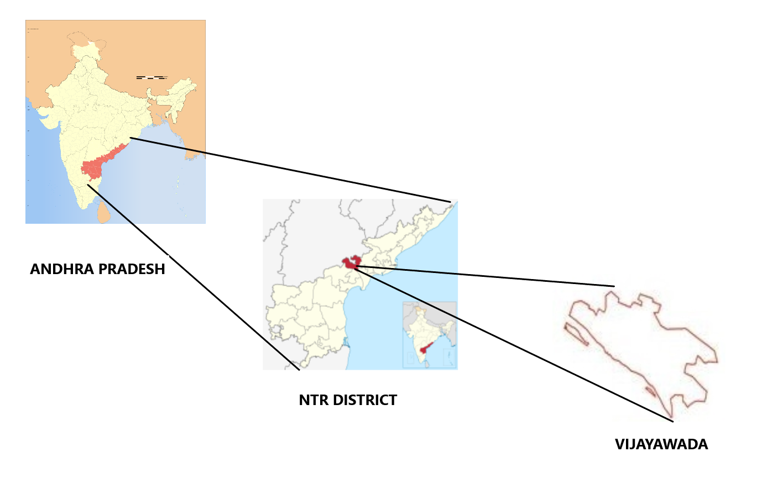**Figure 1.1** Location of Vijayawada

* + 1. **Geography:**

Vijayawada lies on the banks of Krishna River, covered by hills and canals and at an altitude of 11 m (36 ft) above sea level. Three canals originating from the north side of the Prakasam Barrage reservoir — Eluru, Bandar, and Ryves — flow through the city.

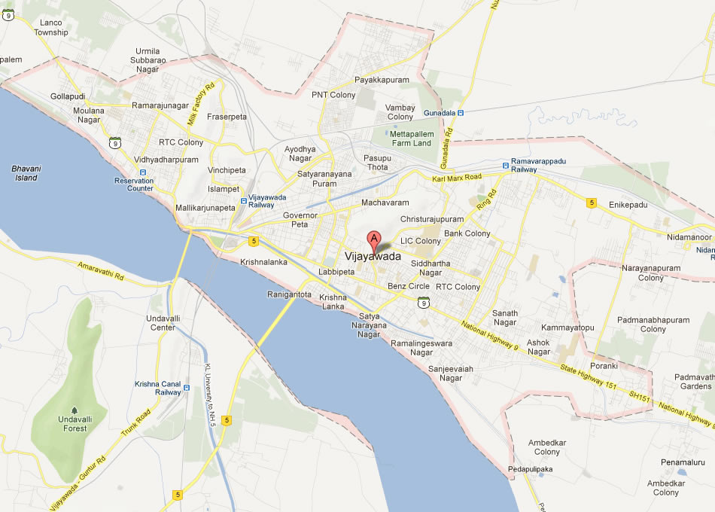

**Figure 1.2** Map of Vijayawada

* + 1. **Demographics:**

The city today,

* + Total area : 61.88 sq. km.
  + Population 1039518
  + Males 527307
  + Females 512211
  + Sex Ratio : 993
  + Literacy : 86.24%
  + Water supply coverage : 77 %
  + Access to comprehensive sewage scheme : 20%

One of every five households do not have access to latrine facility.

* 1. **Scope of the Study:**

The scope of the study is to assess & acknowledge the ground water quality at various distinctly chosen locations within Vijayawada City.

* + 1. **Need for the Study:**

There are many reasons why a global groundwater quality assessment is needed:

* Human activities and climate variability are increasing the pressure on groundwater resources, but groundwater is an invisible resource that remains out of sight and out of mind for most people.
* Protection of our groundwater resources is necessary for protecting human health, maintaining food supplies and conserving ecosystems.
* Some regions and countries rely on naturally clean groundwater as advanced water treatment is economically infeasible. Knowing where to source clean groundwater, as well as understanding threats to this resource, is therefore important.
  + 1. **Objectives:**

The objectives of the project are mentioned below:

* Preparation of thematic maps using Survey of India toposheet and satellite imagery.
* Collection of ground water samples at different locations
* Testing the quality of ground water samples of different locations
* Assessment of quality of ground water samples with respect to the standards.
* To find the integrity of each ground water sample collected at various location in Vijayawada and to work out ways for the same for domestic purposes.
* Identification of recharge structure sites & locating the wells in a particular area using GIS application.
* Preparation of final ground water prospectus maps to narrow down the area of ground water prospects for future exploration programs by integrating spatial and attribute database on ARC/VIEW & GIS Platform.
  1. **GIS:**

GIS is an acronym for Geographic Information Systems. In detail GIS are decision support computer-based systems for collecting, storing, presenting and analyzing spatial information. An information system is a set of processes executed on raw data, to produce information, which will be useful in decision making. GIS is a general-purpose technology for handling geographic data in digital form, and satisfying the following specific needs, among others.

* The ability to preprocess data from large stores into a form suitable for analysis including operation such as reformatting, change of projection, resampling and generalization.
* Direct support for analysis and modeling such that, form of analysis calibrations of models, forecasting and prediction all handled through instructions to the GIS.

Post processing of results, including such operations is reformatting tabulation, report generation and mapping. The GIS or geographic features are combined from map features

1. Point
2. Polygon
3. Line
   * 1. **Components of GIS:**

Geographical information systems have important components like,

* Computer hardware
* Software modules
* The organization aspects.
  + - 1. **Computer Hardware:**

The Hardware components of a GIS include – control processing unit (CPU) which is linked to mass storage units such as hard disk drives and tape drives, peripherals such as digitizer or scanner, printer or plotter and visual display unit (VDU) shows the major hardware components of a GIS.

* + - 1. **GIS Software Modules:**

The software package for a GIS consists of four basic technical modules,

* Data input and verification
* Data storage and Database Management
* Data transformation and manipulation.
* Data output and presentation.
  + 1. **Data Structures**

In GIS the Data Structure is of 2 types,

* + - 1. **Raster Data Structure:** It is the cellular organization of spatial data. The Simplest raster data structure consists of an array of grid cells.

1. Simple Raster Array.
2. Hierarchical Raster structures.
   * + 1. **Vector Data Structure:** Vector representation is mainly based on the three Main geographical entities points, lines and polygon.

a) Whole polygon structure.

b) Dual independent map encoding file structure

c) Arc- node structure.

d) Relational structure.

e) Digital line graphs.

**1.6.3 Spatial Database Creation:**

In GIS, topology is the term used to describe the geometric characteristic of objects, which do not change under transformations and are independent of any coordinate system. The topological characteristics of an object are also independent of scale of measurement.

Topology as it relates to spatial data and non-spatial data consists of three elements, namely adjacency, containment and connectivity. Broadly, topology can be explained in two ways. Topology consists of metric aspects of spatial relations, such as size, shape, distance and direction. Many spatial relations between objects are topological in nature, including adjacency, containment and overlap.

The geometric relationship between spatial entities and corresponding attributes are very crucial for spatial analysis and integration in GIS. In topology creation both the spatial and attribute data are linked from which different parameter maps are generated. These maps depict the spatial distribution of non-spatial information on spatial locations. The spatial database relevant for this study is Location map.

* + 1. **Attribute Database Creation:**

Attributes are the characteristics of the map features and hold the descriptive information about the geographic features. Attributes are the non-spatial data associated with time and area entities.

|  |  |  |
| --- | --- | --- |
| **Theme** | **Data Type** | **Description** |
| City Boundary | Polygon | City Boundary |
| Major Roads | Line | - |
| Railway Lines | Line | - |
| Internal Roads | Line | - |
| Buildings | Point | Building types like Government, Educational, Worship, Commercial, Residential, Hotel & Emergency |

**Table 1.1** Attribute notations

* 1. **Maps:**
     1. **Base Map:**

The study area base Map is prepared by using Survey of India topographic maps on 1:50,000 scale. All the settlements, road network, water bodies and forest areas are taken into consideration. By comparing the Survey of India topographic maps with that of the satellite image the size of all the settlements are increased and updated. The aerial extent of the study area is 1171sq. km. The Base Map contains the following details.

1. Rivers/Streams
2. All water bodies both perennial and ephemeral
3. Canals
4. National highways
5. State highways
6. Metalled and unmetalled roads connecting all the habitations
7. Railways
8. Cities/major towns/villages.
9. International, State, District, Taluk/Tehsil boundaries. (from Toposheet).

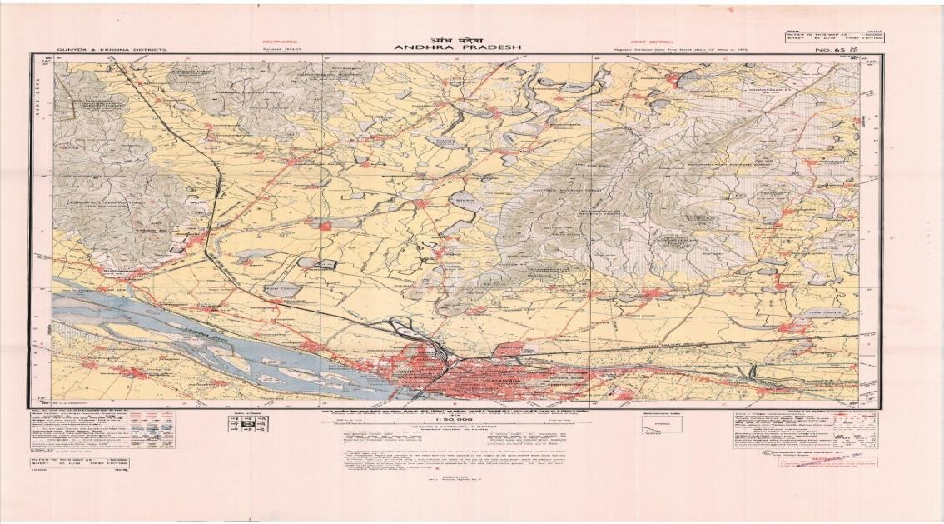

**Figure 1.3** Vijayawada Toposheet/Base Map

**CHAPTER 2**

**LITERTATURE REVIEW**

**CHAPTER 2**

**LITERATURE REVIEW**

Recently various authors carried out extensive studies on ground water quality and its suitability for various purposes. Application of agricultural chemicals, dumping industrial and domestic wastes at the land surface or within the unsaturated zone may have considerable impact on the groundwater quality.

**Assessment of water quality using GIS techniques and water quality index in reservoirs affected by water diversion – 2020.**

**Authors: Francis I. Oseke , Geophery K. Anornu , Kwaku A. Adjei , Martin O. Eduvie.**

Samples collected were analyzed for different chemical properties. The obtained values were evaluated and compared with the standard permissible limits. There are many factors capable of influencing the water chemistry of the receiving region, such as the diversion route dynamics. The water should be continuously monitored and its quality preserved.

**“Groundwater potential in a semi-arid region” of A.P using GIS.**

**Author: K. S. R. MURTHY.**

Continuous and adequate supplies of potable water from ground reservoirs are important for sustained agriculture, industry and domestic use throughout huge semi-arid regions of India. The present paper describes an approach to investigating groundwater potential over extensive geographical areas and illustrates its potential with reference to watershed planning in the large Varaha River Basin (VRB), Andhra Pradesh, India. The method involves the creation of a systematic database of information from satellite data for reconnaissance survey before going for field exploration. Colour composite images from Landsat Thematic Mapper and Indian Remote Sensing (IRS) satellite were used to interpret various thematic maps of the Varaha River basin. SPOT 1 MLA data of band 3 on a 1:250 000 scale was used for improving the accuracy of interpretation of topographic units due to its higher resolution and stereo coverage. Slope and other coverage were derived from topographic maps.

**” Geomorphological and Ground Water Study in Eastern Doon Valley and its surrounding” Indian Institute of Remote Sensing (NRSA).**

**Authors: Sri S.K SRIVASTAV**

The present study has been undertaken to study the geomorphology and delineates the prospective ground water sources in the Eastern Doon valley, and its surroundings falling in the newly formed state of Uttaranchal for this purpose, the satellite imagery (PAN and LISS III) provided by IRS have been digitally enhanced using various techniques to improve the visual interpretability. These enhanced images were visually interpreted to group different landform and geomorphic units existing in the area and to understand the process of their evolution other parameters which control the occurrence and movement of ground water, such as Lithology / Rock type, Structure Land use/Land-cover, drainage density were also interpreted using satellite imagery in conjunction with the existing maps and literature, and different overlays were prepared. Well data were collected from different government departments and analysed. Based upon the well data, different maps like static water table map aquifer thickness map, well discharge map, and well yield factor map were prepared.

**Water quality analysis of Bhadravathi taluk using GIS – 2012.**

**Authors: Rajkumar V. Raikar, Sneha M K.**

The paper presents a case study on the water quality analysis carried out at the Bhadravathi Taluk, Karnataka, India. Geographic information system (GIS) is used to represent the spatial distribution of the parameters and raster maps were created. The maps showing the spatial distribution of various physico-chemical parameters are developed using GIS facilitated in identifying the potential zones of drinking water quality.

**Use of Geographic Information Systems (GIS) in Water Resources – 1996.**

**Authors: Vassilios A. Tsihrintzis , Rizwan Hamid.**

GIS applications are presented including surface hydrologic and groundwater modeling, etc. for urban and agricultural areas, and other related applications. In order to stress the importance of GIS in water resources, applications related to this area are addressed and evaluated for efficient future research and development. Current GIS applications are presented including surface hydrologic for urban and agricultural areas, and other related applications.

**Geospatial Assessment of Ground Water Quality and Associated Health Problems in the Western Region of India.**

**Authors: Rani Singh, Pallavi Upreti, Khaled S. Allemailem, Ahmad Almatroudi, Arshad Husain Rahmani, Ghadah M. Albalawi**

The article presents a case study to access the quality and suitability of groundwater for drinking purposes in western drier parts of India in the state of Rajasthan. Based on collected data, selected hydro-geochemical parameters, the quality of water has been determined and Water Quality Index (WQI) have been prepared using GIS applications. Applying the Inverse Distance Weighting method, WQI values for 89 villages in the area have been computed, while 68% of the region had “poor water quality”, only 32% is sustained as ‘good water’ for consumption. The north-eastern region with a WQI value of >250 had the worst water quality. Furthermore, the existing water quality is also examined for influencing two water borne diseases. The study thus establishes that the majority of groundwater in the region is beyond the permissible safer consumption limits, and a large population of the region, which is directly dependent on groundwater sources, is prone to water borne health hazards. A significantly high correlation was observed between Specific Water Quality Parameters in the region and prevalence of gastroenteritis.

**CHAPTER 3**

**METHODOLOGY**

**CHAPTER 3**

**METHODOLOGY**

AIM

COLLECTION OF WATER SAMPLES

ANALYSIS OF WATER SAMPLES

GIS APPLICATIONS

PREPARATION OF BASE MAP

OUTPUT

CONCLUSION

* 1. **Study Area Selection:**

Three samples are collected from each of the sixteen locations identified in Vijayawada city and are analyzed in the laboratory. The samples are collected in the months of March-April 2022

|  |  |  |  |
| --- | --- | --- | --- |
| **S.No.** | **Location** | **Latitude** | **Longitude** |
| 1 | Patamata | 16.4950° N | 80.6618° E |
| 2 | Gandhi Nagar | 23.2156° N | 72.6369° E |
| 3 | Machavaram | 16.5193° N | 80.6522° E |
| 4 | Nidamanuru | 16.5094° N | 80.7203° E |
| 5 | Labbipet | 16.5033° N | 80.6389° E |
| 6 | Moghalrajpuram | 16.5060° N | 80.6415° E |
| 7 | Gundala | 16.5233° N | 80.6688° E |
| 8 | Krishna Lanka | 16.5062° N | 80.6225° E |
| 9 | Auto Nagar | 16.5017° N | 80.6779° E |
| 10 | Patamatalanka | 16.4947° N | 80.6535° E |
| 11 | Governorpet | 16.5139° N | 80.6293° E |
| 12 | Enikepadu | 16.5142° N | 80.7058° E |
| 13 | Kanuru | 16.2858° N | 81.2546° E |
| 14 | Ramavarappadu | 16.5256° N | 80.6843° E |
| 15 | Gollapudi | 16.5400° N | 80.5828° E |
| 16 | Ayodhya Nagar | 21.1144° N | 79.1079° E |

**Table 3.1** Details of Sampling Location and Coordinates

* 1. **Sample Collection:**

The Ground water samples have been collected from fifteen locations in Vijayawada. The collected samples were labelled properly indicating the exact coordinates of point of collection and are used to plot on prepared Thematic Map based on the Toposheet (Figure 1.3). The base map or toposheet of Vijayawada is prepared by Survey of India, Hyderabad.

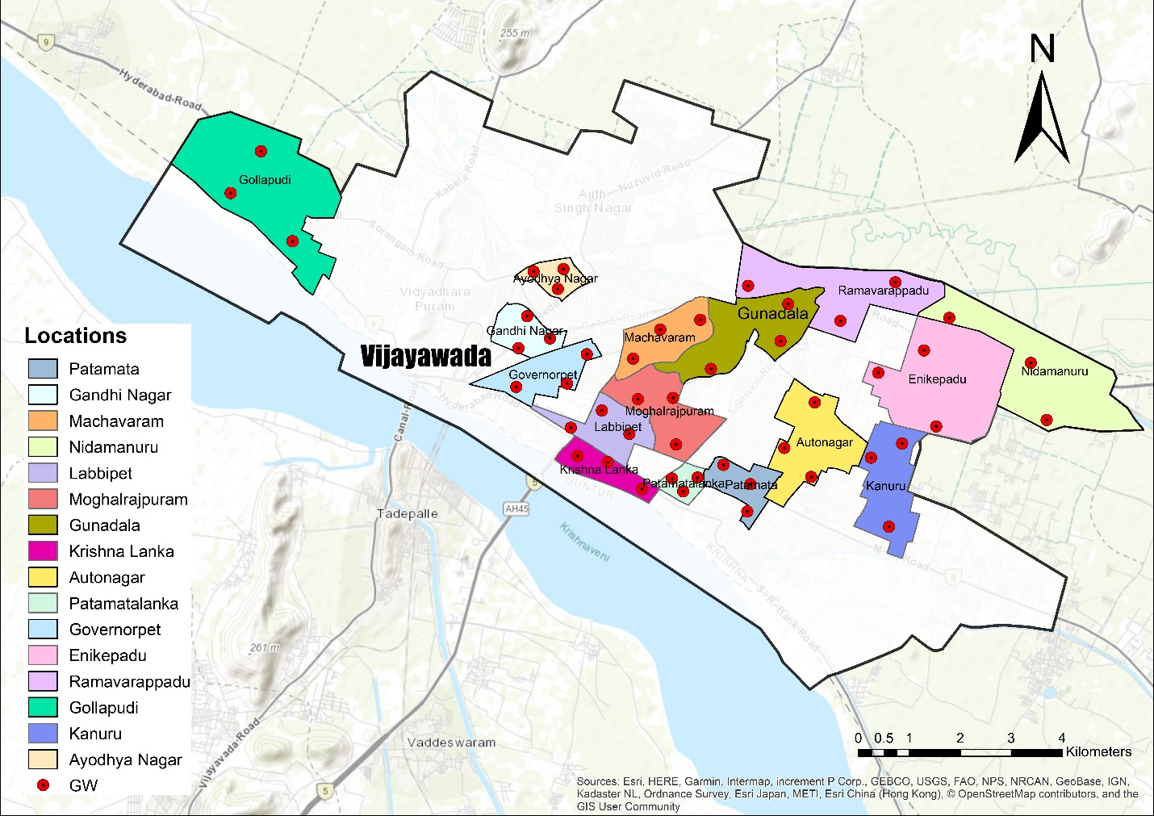

**Figure 3.1** Sample locations on Thematic Map

* + 1. **Collection of water samples at different locations:**

Every sample collecting location coordinates are captured by geo tagging snapshot.

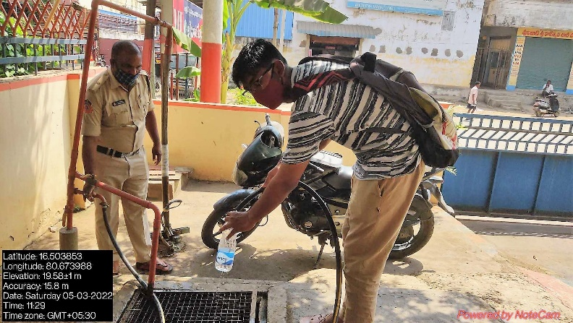

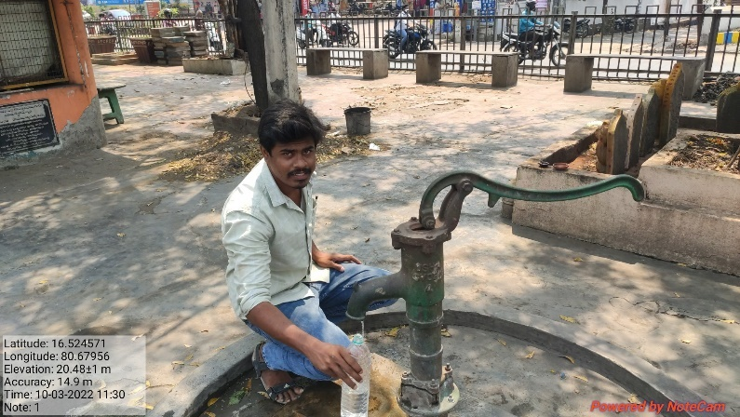

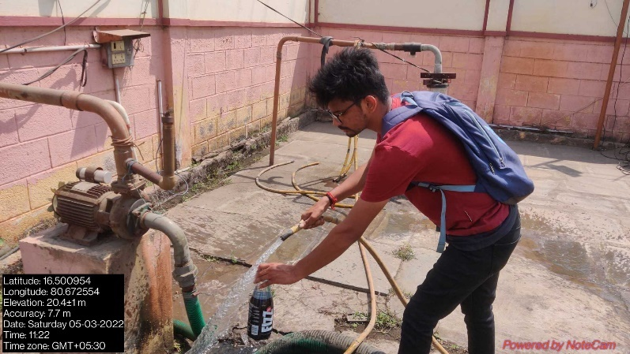

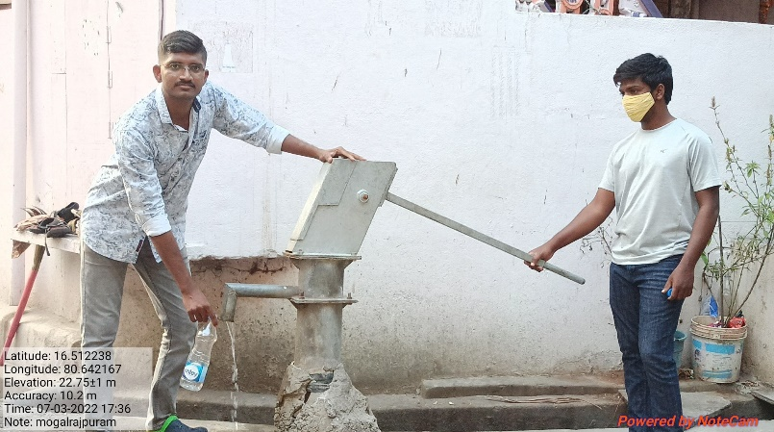

**CHAPTER 4**

**ANALYSIS OF WATER SAMPLES**

**CHAPTER 4**

**ANALYSIS OF WATER SAMPLES**

* 1. **Parametric Analysis:**

The parametric analysis carried out to assess the ground water quality are **Physical and Chemical Parameters.**

* 1. **.1 Chemical Tests:**

Chemical Tests performed for water analysis:

|  |  |  |
| --- | --- | --- |
| **Test Conducted** | **Units** | **Principle of the method** |
| pH | - | Digital pH meter. |
| Alkalinity | mg/L CaCO3 | Titrate with stand. H2SO4  using Phenolphthalein indicator. |
| Electrical Conductivity | µmhos/cm | Digital conductivity meter. |
| Chlorides | mg/L | Titration with stand. AgNO3 using K2Cr2O7 as indicator. |
| Total Hardness | mg/L | Titration with stand. EDTA using indicator & 1ml of Ammonia buffer Sol. |
| Permanent Hardness | mg/L | Titration with stand. EDTA using Eriochrome black T indicator & 1ml of Ammonia buffer Sol. |
| Temporary Hardness | mg/L | Presence of bicarbonates of calcium and magnesium ions. |
| Calcium (Ca) | mg/L | Titration with stand. EDTA using murexide indicator & 1ml of Sodium hydroxide buffer Sol. |
| Magnesium (Mg) | mg/L | Titration with stand. EDTA using murexide indicator & 1ml of Sodium hydroxide buffer Sol. |
| Sulphate (SO4) | mg/L | Quantitative precipitation by barium chloride |

**Table 4.1** Chemical Tests

1. **Physical Tests:**

Physical Tests performed for water analysis:

|  |  |  |
| --- | --- | --- |
| **Test Conducted** | **Units** | **Principle of the method** |
| Colour | - | Colour in water may be caused by the presence of minerals such as iron and manganese or by substances of vegetable origin such as algae and weeds. |
| Turbidity | NTU | An infrared diode shines infrared light into the medium. |
| Total Solids | mg/L | Evaporation. |
| Total Suspended Solids | mg/L | Evaporation. |
| Total Dissolved Solids | mg/L | Evaporation. |
| Odour | - | Odour and taste are associated with the presence of living microscopic organisms; or decaying organic matter including weeds, algae; or industrial wastes containing ammonia, phenols, halogens, hydrocarbons. |
| Taste | - |

**Table 4.2** Physical Tests

**4.2 Experimental Procedures:**

**4.2.1 Determination of pH:**

The effect of pH on the chemical and biological properties of liquids makes its determination very important. It is one of the most important parameters in water chemistry and is defined as -log [H+], and measured as intensity of hydrogen ion concentration on a scale ranging from 0-14. If free H+ are more it is expressed as acidic (i.e., pH<7) and if OH- ions are more than it is expressed as alkaline (i.e., pH> 7).

In natural waters, pH is governed by the equilibrium between carbon dioxide / bicarbonate / carbonate ions and ranges between 4.5 and 8.5 although mostly basic. It tends to increase during the day largely due to the photosynthetic activity (consumption of carbon di-oxide) and decreases during night due to respiratory activity. Wastewater and polluted natural waters have pH values lower or higher than 7 based on the nature of the pollutant.

**Apparatus**:

Glass electrode, Reference electrode (mercury/calomel or silver/silver chloride) and pH meter.

**Procedure**:

Electrometric method: pH is determined by measuring the Electromotive Force (E.M.F) of a cell comprising an indicator electrode (an electrode responsive to hydrogen ions such as a glass electrode) immersed in the test solution and the reference electrode (usually a mercury/calomel electrode). Contact between the test solution and the reference electrode is usually obtained by means of a liquid junction, which forms a part of the reference electrode. E.M.F of this cell is measured with a pH meter, that is, a high impedance voltmeter calibrated in terms of ph. The electrode is allowed to stand for 2 minutes to stabilize before taking reading for reproducible results (at least ±0.1 pH units).

**4.2.2 Determination of Turbidity:**

Insoluble particles of soil, inorganic and organic materials and other micro-organisms impede (obstruct) passage of light by scattering and absorbing the light rays. The interference to passage of light is turbidity. It is usually caused by the finely dissolved and sometimes suspended particles of clay loam sand and microscopic organisms all in suspension.

Turbidity is measured photometrically by determining the quantity of light of given intensity absorbed / scattered.

Jackson turbidity meter and Nephelo turbidity meter in generally used to measure turbidity of water samples. Jacksons turbidity meter in generally is based on light absorption and nephelo turbidity meter is based on intensity of light scattered by the sample, taking a reference with standard turbidity meter suspensions.

Nephelometric turbidity meter is generally used for samples with low turbidity and expressed as NTU or mg/lt. For portable water allowable turbidity is between 5 to 10 mg/lt.

**Apparatus:**

1. Nephelometric turbidity meter; 2. Sample Tubes.

**Procedure:**

1. Switch on the instrument and allow sufficient warm-up period.
2. Take distilled water or bank solution in the test tube holder and close the lid. Make sure that the mark on the test tube coincides with mark on the panel.
3. Select required range for measurement.
4. Adjust the displayed to ‘000’ by adjusting set zero knob.
5. Remove the test tube containing distilled water and insert another test tube containing standard solution (say 100 NTU or 400 NTU). Place it in test tube holder.
6. Adjust the calibrate knob so that the display reach the standard solution value.
7. Again check ‘0’ display with distilled water. The instrument is now calibrated.

Place the given sample whose turbidity is to be determined in the test tube and take the reading in NTU.

**4.2.3 Determination of Alkalinity:**

Alkalinity of water is a measure of its capacity to neutralize acids. It is primarily due to salts of weak acids, although weak or strong bases may also contribute. Alkalinity is significant in many uses and treatments of natural waters and wastewaters. Because the alkalinity of many surface waters is primarily a function of carbonate, bicarbonate, and hydroxide content, it is taken as an indication of the concentration of these constituents.

It is expressed in terms of CaCO3 equivalent to hydrogen ions neutralized. The major portion of alkalinity in natural water is caused by carbonates, bicarbonates and hydroxides which may be ranked in order of their association with high pH values.

Highly alkaline water leads to caustic embrittlement and causes deposition of precipitates and boiler tubes. Bicarbonates of calcium and magnesium include temporary hardness to water. Boiler water always contains carbonates and hydroxide alkalinity, chemically treated water (lime or lime soda ash softening water) will be alkaline due to the presence of carbonates and excess hydroxide. High alkalinity in natural water will favor the growth of algae and phytoplankton.

**Apparatus**:

1. Burette 2. Pipette 3. Erlenmeyer flasks 4. Indicator solutions

**Reagents**:

1. Standard Sulphuric Acid (0.02 N)

2. Phenolphthalein indicator

3. Methyl orange indicator

**Procedure:**

Phenolphthalein Alkalinity:

1. Take 25ml of sample in a conical flask.

2. Add 3-4 drops of phenolphthalein indicator. If the pH of sample is above 8.3, sample turns

pink.

3. Titrate with 0.02 N H2SO4 in a burette till the colour disappears.

4. Note down the volume of H2SO4 added (V1)

**Calculation**: Phenolphthalein alkalinity in mg/L as CaCO3 = $\frac{V*N*50*1000 }{Volume of sample taken}$

**4.2.4 Determination of Electric Conductivity:**

The electrical conductivity is a total parameter of dissolved, dissociated substances. Its value depends on the concentration and degrees of dissociation of the ions as well as the temperature and migration velocity of the ions in the electric field.

**Apparatus:**

1. Conductivity meter with measuring cell; 2. Beaker; 3. Thermometer

**Procedure:**

Note: If standard KCl solution conductivity is known at different temperature. This calibration method is preferable.

1. Select COND mode

2. After thoroughly cleaning, immerse the cell in the standard solution say 0.1N KCl which has specific conductivity of the order of 0.01412 at 300C. (=14.12μs)

3. Select 20ms range (select range as per standard KCl solution conductivity).

4. Set conductivity (as per temperatures) using CELL constant POT and then lock using lock nut. Now calibration is over.

**CALIBRATION USING COND (25 0C) MODE:**

Note: If standard KCl solution conductivity is not known at different temperature (only at 250o C specific conductivity known). This calibration method is preferable.

1. Select TEMP mode

2. Set temperature of standard solution using TEMP

3. Select COND (250o C) mode

4. After thoroughly cleaning, immerse the cell in the standard solution, say 0.1N KCL (aqueous) which has specific conductivity of the order of 0.01288 = (12.88μs) at 250C

5. Select 20ms range.

6. Set conductivity (as per 250o C temperature) using CELL constant POT and then lock using lock nut. Now calibration is over.

**4.2.5 Determination of Total Solids, Total Suspended Solids & Total Dissolved Solids:**

Normally the sewage water sample contains 99.9 % water and 0.1% solids. The term solids in water and waste water for a sanitary engineer refers to as the matter which remains as a residue after evaporation and subsequent drying at specified temperature of 100 to 105 C. the total solids is considered as the sum of dissolved solids and suspended solids.

1. **Total Solids**: They indicate both organic and inorganic matter. Organic solids are also called as volatile solids and inorganic solids are also called non-volatile solids.
2. **Suspended Solids**: These are of two types: settleable and non-settleable solids. Settleable solids are those which will settle down in the sedimentation tank with a usual detention period of 1 to 3 hours. Non-settleable solids will not settle down and are usually volatile in nature.
3. **Dissolved Solids**: They are present in dissolved state and can be determined indirectly.
4. **Total Solids:**

**Apparatus:**

1. Evaporating Dish (Gooch Crucible); 2. Oven (103o C); 3. Muffle Furnace (550 ± 50o C);

4. Weighing Balance

**Procedure:**

1. Take a clean crucible and make it completely dry in oven, cool it and take its initial weight as W1
2. Add 25 ml of well mixed sample to crucible.
3. The sample is evaporated by heating at 100 to 103o C for 1 hour.
4. The residue left in the dish is weighed after cooling as W including weight of the dish.

**Total Solids** in mg/L = $\frac{ \left(W2-W1\right)*1000*1000}{25}$

1. **Suspended Solids:**

**Apparatus:**

1.Vaporating Dish; 2. Oven (103o C); 3. Filter Paper; 4. Weighing Balance.

**Procedure**:

1. Measure the initial eight of clean filter paper (F1).
2. 100 ml of sample is taken and passed through filter paper by placing on the funnel.
3. The filter paper is removed and dried in oven at 103o C.
4. It is cooled and final weight in notes as (F2).

**Suspended Solids** in mg/L = $\frac{ (F2-F1)*1000*1000}{25}$

1. **Dissolved Solids:**

**Apparatus:**

1.Vaporating Dish; 2. Oven (103o C); 3. Filter Paper; 4. Weighing Balance.

**Procedure:**

1. Determine the initial weight of the evaporating dish (D1)
2. Collect about 50 ml of filtrate from the above sample and pour it into the dish.
3. Place the dish along with the filtrate in an oven at 100 to 103o C and evaporate the filtrate sample. (Under any circumstance the sample should not be boiled).
4. When the sample is completely evaporated from the dish, take out from the oven, take out from the oven, cool to lab temperature and note down the weight of the dish as (D2).

**Dissolved Solids** in mg/L =

* + 1. **Determination of Chloride Content:**

Chloride occurs in all natural waters in widely varying concentrations. Chloride in the form of chlorine ions is one of the major inorganic anions in water and waste water; in potable water the salty taste produced by chloride concentration is variable and dependent on the chemical composition of water. Some water containing 250mg/l may have a detectable salty taste if the cation is sodium. On the other hand the typical salty taste may be absent in water containing as much as 100mg/l, when the predominant cations are calcium and magnesium.

**Apparatus:**

1. Burette; 2. Pipette; 3. Conical flask

**Reagents:**

1. Chloride free distilled water

2. Potassium chromate indicator.

3. Standard silver nitrate (0.0141N)

4. Standard sodium chloride (0.0141N)

**Procedure:**

1. Take 25ml of sample in conical flask.

2. Adjust its pH between 7.0 and 8.0 either with sulphuric acid or sodium hydroxide

solution. Otherwise AgOH is formed at high pH level.

3. Add 1ml of potassium chromate to get light yellow colour.

4. Titrate with standard silver nitrate solution till colour change from yellow to brick

red.

5. Note down the volume of silver nitrate added (A).

6. If more quantity of potassium chromate is added, silver chromate may form too soon

or not soon enough.

7. For better accuracy, titrate distilled water in the same manner.

8. Note the volume of silver nitrate added for distilled water (B).

**Calculations:**

Chloride content of the given sample in mg/L = $\frac{\left(A-B\right) * Normality of AgNO3 * 35.46 * 1000}{25}$

**4.2.7 Determination of Total Hardness:**

Total hardness is a measurement of the mineral content in a water sample that is irreversible by boiling. More specifically, total hardness is determined by the concentration of multivalent cations in water. These cations have a positive charge that is higher than 1+. Typically, cations have a charge of 2+. The most common cations present in hard water are Mg2+ and Ca+.

**Apparatus:**

* 1. Water sample; 2. Burette 50ml; 3. Glass funnel; 4.Pipette 1ml; 5.Flask; 6.Dropper;

7. Measuring cylinder

**Reagents**:

EDTA, Eriochrome Black-T, Ammonia Buffer, Distilled water.

**Procedure:**

1. Take a sample volume of 20ml (V ml).
2. Dilute 20ml of the sample in Erlenmeyer flask to 40ml by adding 20ml of distilled water.
3. Add 1 mL of ammonia buffer to bring the pH to 10±0.1.
4. Add 1 or 2 drops of the indicator solution. If there is Ca or Mg hardness the solution turns wine red.
5. Add EDTA titrant to the sample with vigorous shaking till the wine red colour just turns blue.
6. Note the volume of titrant added (V1 ml).

**Calculation:**

Total Hardness in mg/L = $\frac{V1 * N * 100 * 1000}{25}$

V = Volume of the sample taken, ml

V1 = Volume of the titrant used for sample taken, ml

N = Normality of EDTA

* + 1. **Determination of Permanent and Temporary Hardness:**

When the soluble salts of magnesium and calcium are present in the form of chlorides and sulphides in water, we call it permanent hardness because this hardness cannot be removed by boiling.

We can remove this hardness by treating the water with washing soda. Insoluble carbonates are formed when washing soda reacts with the sulphide and chloride salts of magnesium and calcium and thus, hard water is converted to soft water.

**Apparatus:**

1.Burette, 2. Erlenmeyer flask, 3. Pipette, 4. Sample Bottle etc.

**Procedure:**

1. Take 100ml of water sample into a beaker and boil gently for 15-20 minutes.
2. Cool the solution then filter and wash the precipitate several times. Collect both the filtrate into a 250ml volumetric flask and level up to the mark with distilled water. Then, shake well.
3. Take 50ml of solution from volumetric flask with pipette and place into a conical flask.
4. Add 1-5ml NH4OH/NH4Cl buffer solution. It increases the pH level and should be 10. Check the pH with standardize pH meter.
5. Add 2-3 drops 0.1M Mg-EDTA solution and 3-4 drops Eriochrome Black T indicator. Then, shake well and the colour becomes wine red.
6. Fill up the burette with standardized 0.01M EDTA solution. Record the initial burette reading and titrate the water sample with this standard solution.
7. At the end point the colour of the solution turns into blue from wine red. Titrate carefully near the end point.
8. Take the final burette reading. Let, it is V1 ml.
9. Repeat the titration process at least three times.
10. You can run a blank titration for more accurate result. Let, it is V2 ml.

**Calculation:**

The 100ml sample water is dilute into a 250ml volumetric flask

Hence, 50ml dilute water = 100 ᵡ 50/250 ml = 20ml sample water

Now, 20ml of sample water ≡ V ᵡ 1.00mg CaCO3

∴ 1000ml of sample water ≡ V ᵡ 1.00mg ᵡ 1000/20 CaCO3

**4.2.9 Determination of Calcium and Magnesium:**

One of the factors that establish the quality of a water supply is its degree of hardness. The hardness of water is defined in terms of its content of calcium and magnesium ions. Since an analysis does not distinguish between Ca2+ and Mg2+, and since most hardness is caused by carbonate deposits in the earth, hardness is usually reported as total parts per million calcium carbonate by weight. A water supply with a hardness of 100 parts per million would contain the equivalent of 100 grams of CaCO3 in 1 million grams of water or 0.1 gram in one litre of water. In the days when soap was more commonly used for washing clothes, and when people bathed in tubs instead of using showers, water hardness was more often directly observed than it is now, since Ca2+ and Mg2+ form insoluble salts with soaps and make a scum that sticks to clothes or to the bath tub. Detergents have the distinct advantage of being effective in hard water, and this is really what allowed them to displace soaps for laundry purposes. Calcium in water will be analysed this week by EDTA titration and next week by atomic absorption analysis and the results compared.

**Apparatus:**

1.Burette, 2. Erlenmeyer flask, 3. Pipette, 4. Sample Bottle etc.

**Procedure:**

1. Take 25- or 50-ml sample in a conical flask
2. Add 1 ml NaOH to raise pH to 12.0 and add a pinch of murexide indicator.
3. Titrate immediately with EDTA till pink colour changes to purple. Note the volume of EDTA
4. used (A1).
5. Run a reagent blank. Note the ml of EDTA required (B1) and keep it aside to compare end
6. points of sample titrations.
7. Calculate the volume of EDTA required by sample, C1 = A1 – B1.

**Calculation:**

Calcium as Ca in mg/L = $\frac{C1 * D * 1000}{25}*0.4$

Where

C1= volume of EDTA used by sample (with murexide indicator)

D = mg CaCO3 equivalent to 1 ml EDTA titrant

Magnesium hardness

Magnesium Hardness = Total hardness as CaCO3, mg/L – Calcium hardness as CaCO3, mg/L.

Mg (mg/L) = (Total hardness (as CaCO3mg /L) – Calcium hardness (as mg CaCO3/L)) x 0.243

* + 1. **Determination of Sulphate:**

The turbidimetric method depends on the fact that barium sulphate formed following barium chloride addition to a sample (Equation 2) tends to precipitate in a colloidal form and this tendency is enhanced in the presence of an acidic buffer (consists of magnesium chloride, potassium nitrate, sodium acetate, and acetic acid). These precipitates need to be separated through filtration (using a filter) before sample is analysed for sulphate concentration. This is a very rapid method and can be used for samples with sulphate concentration greater than 10 mg/L (samples can be diluted and then it can be analysed).

Ba2+ + SO4-2 => BaSO4

**Apparatus:** Whatman No. 1 filter paper; Spectrophotometer; Magnetic stirrer.

**Reagent**:

1. Dry Barium Chloride (BaCl2) crystals; 2. Standard Sulphate Solution; 3. Buffer solution.

**Procedure:**

1. Filter the sample though filter paper (Whatman No. 1) and take 50 mL of filtrate in an Erlenmeyer flask.
2. Add 20 mL buffer solution and mix in stirring apparatus. While stirring, add 0.15 g of barium chloride to the sample and stir the sample with the help of magnetic stirrer for about an hour.
3. Measure the absorbance against a distilled water blank (DO NOT ADD BARIUM CHLORIDE TO IT.) at 420 nm using spectrophotometer. Absorbance for the blank sample is taken to correct for sample colour and turbidity.
4. Process the standard solution of different strengths in similar way and record the absorbance for each solution. Plot a standard Sulphate calibration curve on a graph paper from these absorbance values putting strengths (mg/L) on X-axis and absorbance @ 420 nm on Y-axis. Fit a best-fit linear model to the data. Express equation as:

Absorbance value= A+B× Sulphate concentration (in mg/L)

1. Using the standard Sulphate calibration curve (a linear-model; Equation 3), find out Sulphate concentration in the given unknown sample in mg/L.

Sulphate concentration (mg SO4-2 /L) =

* 1. **Testing of Water Samples in Laboratory:**

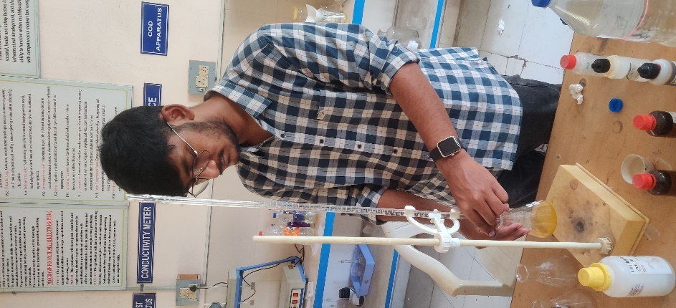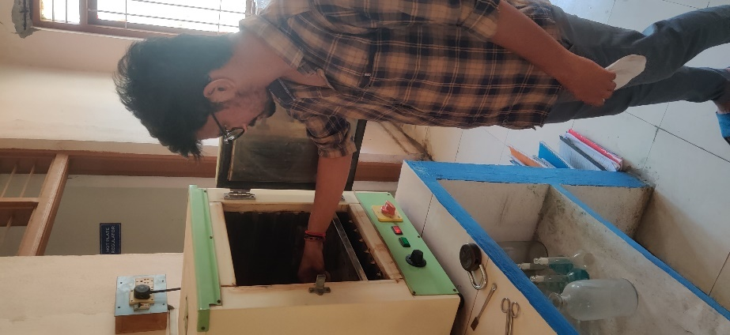

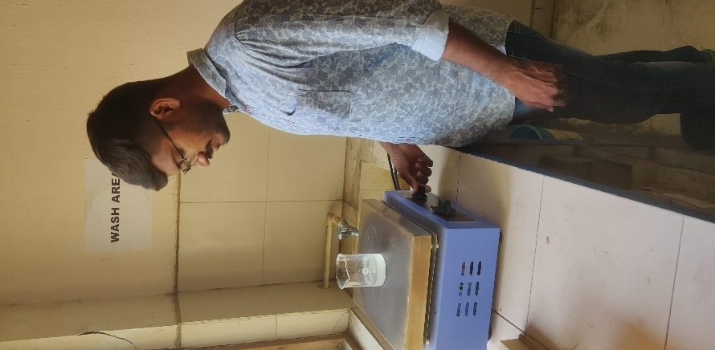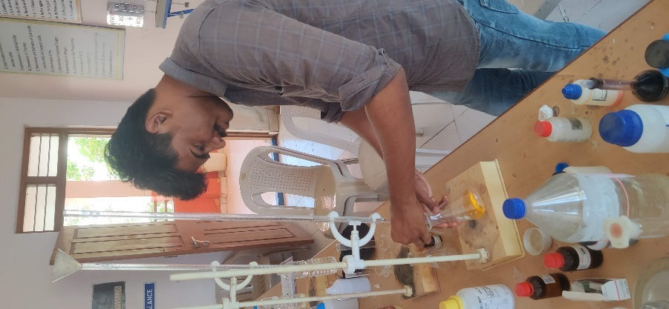

**4.8 Test Results:**

Test Results from analysis of water samples of each individual location and their thematic map are shown below:

**4.8.1 Location 1: Patamata**

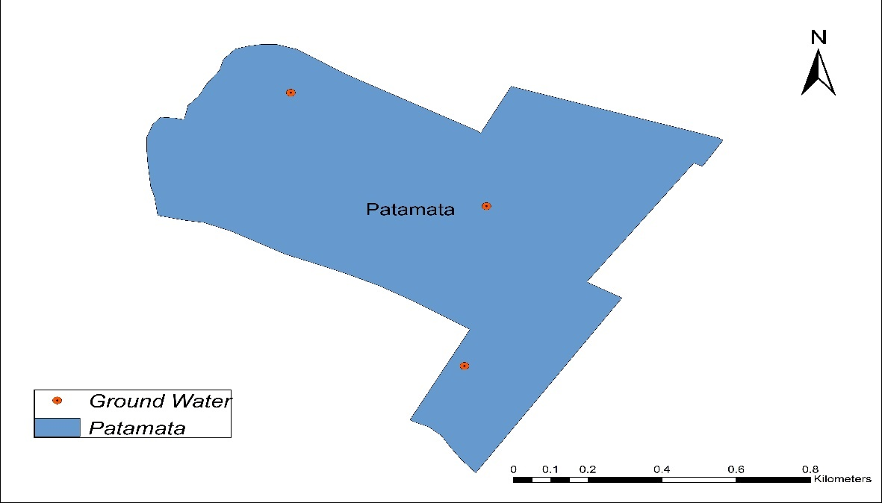

**Figure 4.1** Patamata

|  |  |  |  |  |  |
| --- | --- | --- | --- | --- | --- |
| **TEST** | **UNITS** | **S1** | **S2** | **S3** | **Average** |
| **pH** | - | 7.35 | 7.5 | 7.7 | 7.5 |
| **TURBIDITY** | NTU | 1.1 | 1.2 | 1.2 | 1.2 |
| **TS** | mg/L | 1598 | 1680 | 1723 | 1667 |
| **TSS** | mg/L | 17 | 7 | 11 | 24 |
| **TDS** | mg/L | 1581 | 1673 | 1712 | 1643 |
| **ALKALINITY** | mg/L CaCO3 | 470 | 484 | 498 | 484 |
| **CONDUCTIVITY** | µmhos/cm | 2432 | 2574 | 2634 | 2527.69 |
| **CHLORIDES** | mg/L | 98 | 184 | 141 | 141.84 |
| **TOTAL HARDNESS** | mg/L | 597 | 657 | 619 | 624 |
| **PERMANENT HARDNESS** | mg/L | 91 | 128 | 167 | 128 |
| **TEMPORARY HARDNESS** | mg/L | 506 | 529 | 452 | 496 |
| **Ca** | mg/L | 151.6 | 164.8 | 178 | 165 |
| **Mg** | mg/L | 41.06 | 51.51 | 62.20 | 52 |
| **SO4** | mg/L | 10 | 12 | 14 | 12 |

**Table 4.3** Test Results of Patamata

**4.8.2 Location 2: Gandhi Nagar**

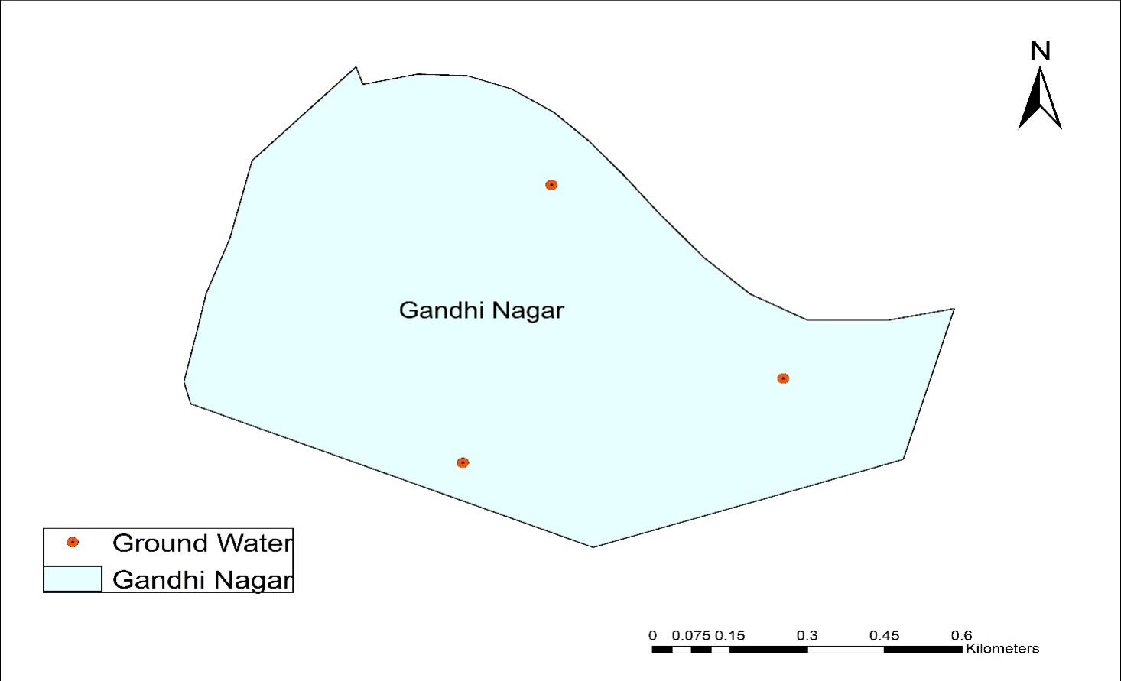

**Figure 4.2** Gandhi Nagar

|  |  |  |  |  |  |
| --- | --- | --- | --- | --- | --- |
| **TEST** | **UNITS** | **S1** | **S2** | **S3** | **Average** |
| **pH** | - | 7 | 7.25 | 7.5 | 7.25 |
| **TURBIDITY** | NTU | 1.2 | 1.1 | 1.1 | 1.1 |
| **TS** | mg/L | 651 | 670 | 691 | 670 |
| **TSS** | mg/L | 12 | 13 | 10 | 13 |
| **TDS** | mg/L | 639 | 657 | 681 | 657 |
| **ALKALINITY** | mg/L CaCO3 | 391 | 440 | 489 | 440 |
| **CONDUCTIVITY** | µmhos/cm | 983 | 1011 | 1048 | 1010.77 |
| **CHLORIDES** | mg/L | 101 | 141 | 181 | 143.9 |
| **TOTAL HARDNESS** | mg/L | 391 | 420 | 450 | 420 |
| **PERMANENT HARDNESS** | mg/L | 151 | 172 | 195 | 172 |
| **TEMPORARY HARDNESS** | mg/L | 240 | 248 | 255 | 248 |
| **Ca** | mg/L | 84.4 | 99.2 | 114 | 100.2 |
| **Mg** | mg/L | 34.26 | 41.79 | 49.81 | 42 |
| **SO4** | mg/L | 24 | 28 | 32 | 28 |

**Table 4.4** Test Results of Gandhi Nagar

**4.8.3 Location 3: Machavaram**

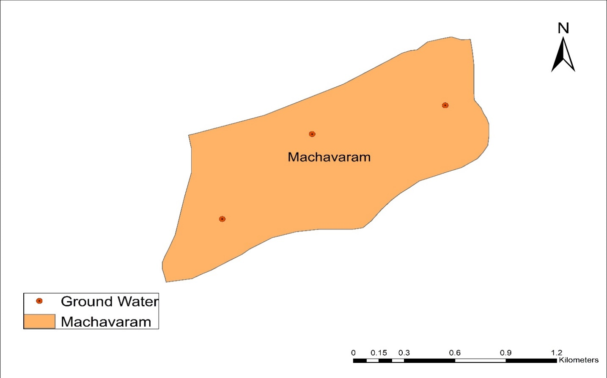

**Figure 4.3** Machavaram

|  |  |  |  |  |  |
| --- | --- | --- | --- | --- | --- |
| **TEST** | **UNITS** | **S1** | **S2** | **S3** | **Average** |
| **pH** | - | 7.25 | 7.3 | 7.4 | 7.3 |
| **TURBIDITY** | NTU | 1.3 | 1.1 | 1.1 | 1.1 |
| **TS** | mg/L | 321 | 350 | 379 | 350 |
| **TSS** | mg/L | 10 | 17 | 11 | 16.37 |
| **TDS** | mg/L | 311 | 333 | 368 | 334 |
| **ALKALINITY** | mg/L CaCO3 | 281 | 300 | 321 | 300 |
| **CONDUCTIVITY** | µmhos/cm | 478 | 513 | 566 | 512.82 |
| **CHLORIDES** | mg/L | 131 | 153 | 177 | 153.19 |
| **TOTAL HARDNESS** | mg/L | 571 | 576 | 642 | 596 |
| **PERMANENT HARDNESS** | mg/L | 161 | 180 | 201 | 180 |
| **TEMPORARY HARDNESS** | mg/L | 410 | 396 | 441 | 416 |
| **Ca** | mg/L | 75.6 | 83.2 | 91.6 | 85 |
| **Mg** | mg/L | 87.72 | 94.28 | 101.33 | 96 |
| **SO4** | mg/L | 29 | 32 | 34 | 32 |

**Table 4.5** Test Results of Machavaram

**4.8.4 Location 4: Nidamanuru**

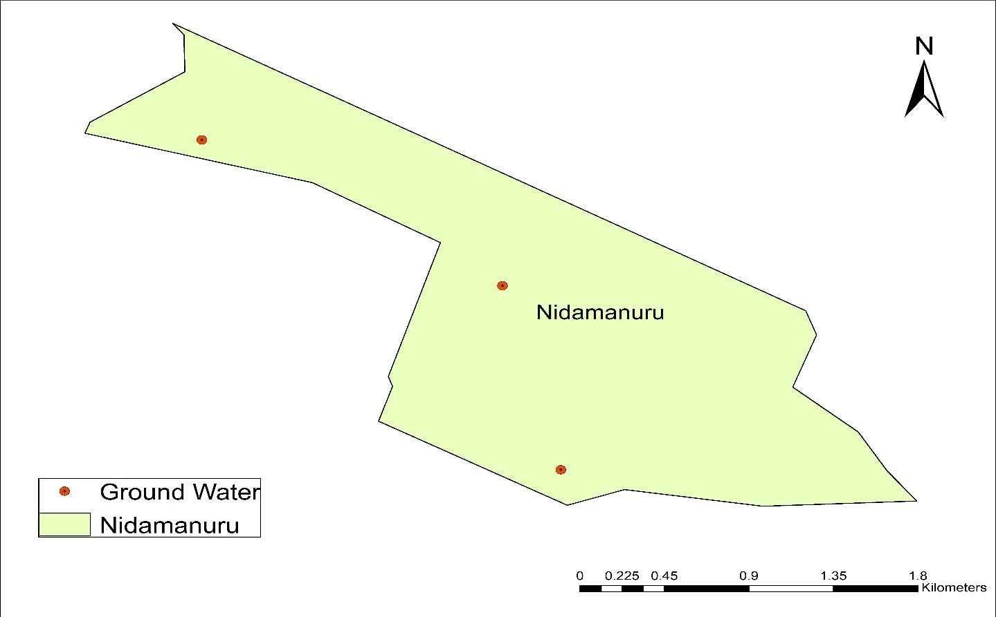 **Figure 4.4** Nidamanuru

|  |  |  |  |  |  |
| --- | --- | --- | --- | --- | --- |
| **TEST** | **UNITS** | **S1** | **S2** | **S3** | **Average** |
| **pH** | - | 7.45 | 7.52 | 7.7 | 7.52 |
| **TURBIDITY** | NTU | 1.1 | 1.2 | 1.3 | 1.3 |
| **TS** | mg/L | 1621 | 1652 | 1684 | 1652 |
| **TSS** | mg/L | 14 | 13 | 13 | 8 |
| **TDS** | mg/L | 1607 | 1639 | 1671 | 1644 |
| **ALKALINITY** | mg/L CaCO3 | 281 | 304 | 327 | 304 |
| **CONDUCTIVITY** | µmhos/cm | 2472 | 2522 | 2571 | 2529.23 |
| **CHLORIDES** | mg/L | 219 | 249 | 279 | 249.63 |
| **TOTAL HARDNESS** | mg/L | 561 | 549 | 631 | 580 |
| **PERMANENT HARDNESS** | mg/L | 287 | 308 | 331 | 308 |
| **TEMPORARY HARDNESS** | mg/L | 274 | 241 | 300 | 272 |
| **Ca** | mg/L | 128.4 | 136 | 144.4 | 136 |
| **Mg** | mg/L | 53.70 | 58.32 | 63.42 | 58.32 |
| **SO4** | mg/L | 12 | 16 | 20 | 16 |

**Table 4.6** Test Results of Nidamanuru

**4.8.5 Location 5: Labbipet**

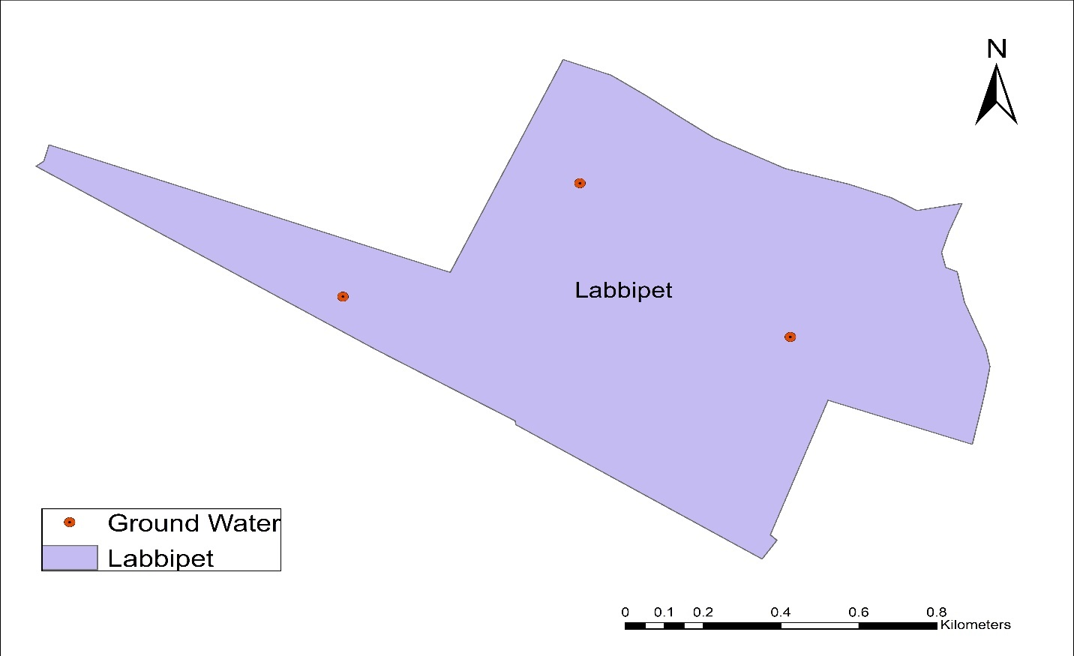

**Figure 4.5** Labbipet

|  |  |  |  |  |  |
| --- | --- | --- | --- | --- | --- |
| **TEST** | **UNITS** | **S1** | **S2** | **S3** | **Average** |
| **pH** | - | 7 | 7.25 | 7.35 | 7.25 |
| **TURBIDITY** | NTU | 1.2 | 1.3 | 1.3 | 1.3 |
| **TS** | mg/L | 1321 | 1341 | 1361 | 1341 |
| **TSS** | mg/L | 12 | 9 | 10 | 4 |
| **TDS** | mg/L | 1309 | 1332 | 1351 | 1337 |
| **ALKALINITY** | mg/L CaCO3 | 572 | 592 | 614 | 592 |
| **CONDUCTIVITY** | µmhos/cm | 2014 | 2049 | 2078 | 2056.92 |
| **CHLORIDES** | mg/L | 153 | 181 | 210 | 181.55 |
| **TOTAL HARDNESS** | mg/L | 579 | 592 | 606 | 592 |
| **PERMANENT HARDNESS** | mg/L | 156 | 188 | 221 | 188 |
| **TEMPORARY HARDNESS** | mg/L | 423 | 404 | 385 | 404 |
| **Ca** | mg/L | 142.4 | 147.2 | 152.4 | 147.2 |
| **Mg** | mg/L | 46.899 | 54.43 | 62.20 | 54.43 |
| **SO4** | mg/L | 32 | 38 | 44 | 38 |

**Table 4.7** Test Results of Labbipet

**4.8.6 Location 6:** **Moghalrajpuram**

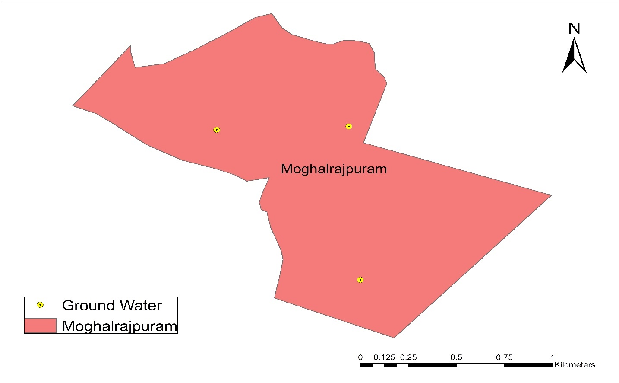

**Figure 4.6** Moghalrajpuram

|  |  |  |  |  |  |
| --- | --- | --- | --- | --- | --- |
| **TEST** | **UNITS** | **S1** | **S2** | **S3** | **Average** |
| **pH** | - | 7.35 | 7.4 | 7.5 | 7.4 |
| **TURBIDITY** | NTU | 1.2 | 1.1 | 1.1 | 1.1 |
| **TS** | mg/L | 1530 | 1549 | 1631 | 1570 |
| **TSS** | mg/L | 13 | 12 | 12 | 19 |
| **TDS** | mg/L | 1517 | 1537 | 1619 | 1551 |
| **ALKALINITY** | mg/L CaCO3 | 445 | 460 | 523 | 476 |
| **CONDUCTIVITY** | µmhos/cm | 2334 | 2365 | 2491 | 2386.15 |
| **CHLORIDES** | mg/L | 131 | 154 | 208 | 164.54 |
| **TOTAL HARDNESS** | mg/L | 310 | 326 | 385 | 340 |
| **PERMANENT HARDNESS** | mg/L | 101 | 119 | 171 | 130 |
| **TEMPORARY HARDNESS** | mg/L | 209 | 207 | 214 | 210 |
| **Ca** | mg/L | 73.6 | 80.4 | 105.6 | 86.4 |
| **Mg** | mg/L | 24.543 | 26.73 | 39.12 | 30.132 |
| **SO4** | mg/L | 98 | 102 | 106 | 102 |

**Table 4.8** Test Results of Moghalrajpuram

**4.8.7 Location 7: Gunadala**

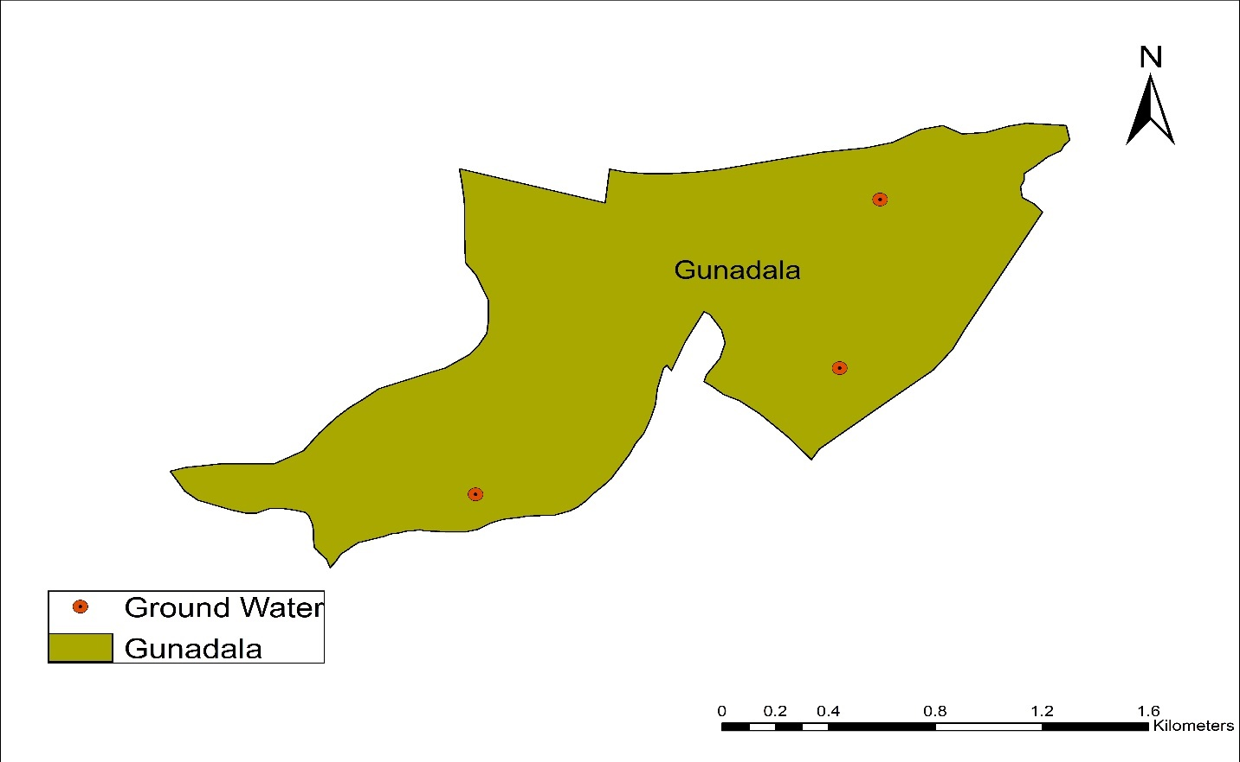

**Figure 4.7** Gundala

|  |  |  |  |  |  |
| --- | --- | --- | --- | --- | --- |
| **TEST** | **UNITS** | **S1** | **S2** | **S3** | **Average** |
| **pH** | - | 7.25 | 7.3 | 7.7 | 7.42 |
| **TURBIDITY** | NTU | 1.1 | 1.2 | 1.2 | 1.2 |
| **TS** | mg/L | 755 | 770 | 844 | 789 |
| **TSS** | mg/L | 13 | 12 | 17 | 7 |
| **TDS** | mg/L | 742 | 758 | 827 | 782 |
| **ALKALINITY** | mg/L CaCO3 | 381 | 395 | 449 | 408 |
| **CONDUCTIVITY** | µmhos/cm | 1142 | 1166 | 1272 | 1203.08 |
| **CHLORIDES** | mg/L | 211 | 235 | 211 | 241.13 |
| **TOTAL HARDNESS** | mg/L | 560 | 580 | 649 | 596 |
| **PERMANENT HARDNESS** | mg/L | 271 | 287 | 354 | 304 |
| **TEMPORARY HARDNESS** | mg/L | 289 | 293 | 295 | 292 |
| **Ca** | mg/L | 160.4 | 166 | 197.2 | 174.4 |
| **Mg** | mg/L | 31.34 | 34.02 | 51.516 | 38.88 |
| **SO4** | mg/L | 10 | 14 | 18 | 14 |

**Table 4.9** Test Results of Gunadala

**4.8.8 Location 8: Krishna Lanka**

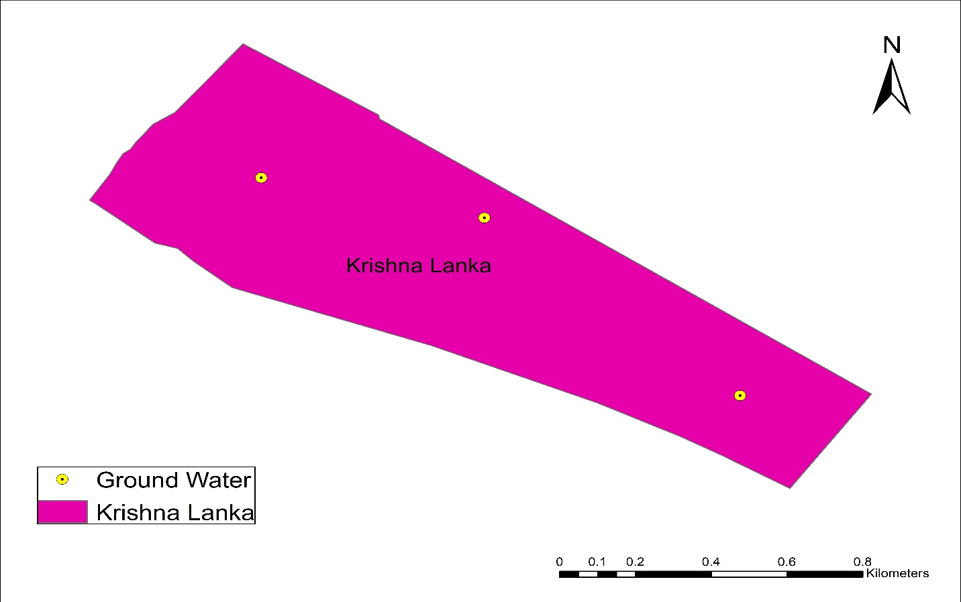

**Figure 4.8** Krishna Lanka

|  |  |  |  |  |  |
| --- | --- | --- | --- | --- | --- |
| **TEST** | **UNITS** | **S1** | **S2** | **S3** | **Average** |
| **pH** | - | 7.2 | 7.1 | 7.5 | 7.3 |
| **TURBIDITY** | NTU | 1 | 1.1 | 1.1 | 1.1 |
| **TS** | mg/L | 751 | 773 | 871 | 798 |
| **TSS** | mg/L | 15 | 14 | 9 | 12 |
| **TDS** | mg/L | 736 | 759 | 862 | 786 |
| **ALKALINITY** | mg/L CaCO3 | 480 | 501 | 569 | 516 |
| **CONDUCTIVITY** | µmhos/cm | 1132 | 1168 | 1326 | 1209.23 |
| **CHLORIDES** | mg/L | 101 | 111 | 196 | 136.16 |
| **TOTAL HARDNESS** | mg/L | 752 | 764 | 837 | 784 |
| **PERMANENT HARDNESS** | mg/L | 106 | 119 | 202 | 142 |
| **TEMPORARY HARDNESS** | mg/L | 646 | 645 | 635 | 642 |
| **Ca** | mg/L | 80.8 | 86.4 | 116.4 | 94.4 |
| **Mg** | mg/L | 124.41 | 127.81 | 147.25 | 133.16 |
| **SO4** | mg/L | 32 | 36 | 40 | 36 |

**Table 4.10** Test Results of Krishna Lanka

**4.8.9 Location 9: Auto Nagar**

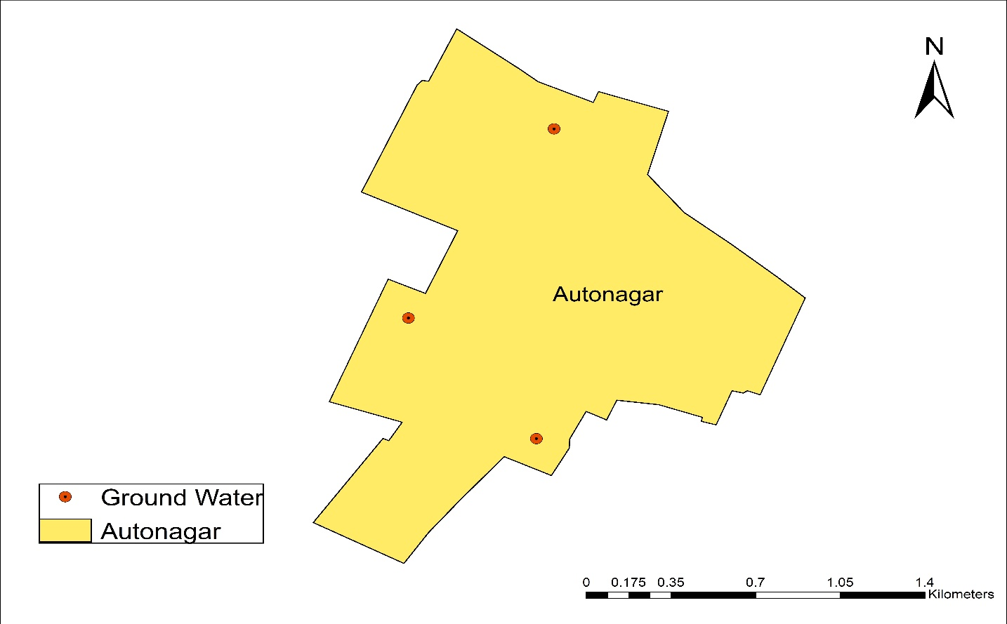

**Figure 4.9** Auto Nagar

|  |  |  |  |  |  |
| --- | --- | --- | --- | --- | --- |
| **TEST** | **UNITS** | **S1** | **S2** | **S3** | **Average** |
| **pH** | - | 7.45 | 7.5 | 7.7 | 7.52 |
| **TURBIDITY** | NTU | 1.2 | 1.3 | 1.3 | 1.3 |
| **TS** | mg/L | 997 | 1001 | 1081 | 1026 |
| **TSS** | mg/L | 20 | 20 | 12 | 7 |
| **TDS** | mg/L | 997 | 981 | 1069 | 1019 |
| **ALKALINITY** | mg/L CaCO3 | 591 | 602 | 681 | 624 |
| **CONDUCTIVITY** | µmhos/cm | 1503 | 1509 | 1645 | 1567.69 |
| **CHLORIDES** | mg/L | 191 | 205 | 282 | 226.94 |
| **TOTAL HARDNESS** | mg/L | 699 | 710 | 789 | 732 |
| **PERMANENT HARDNESS** | mg/L | 172 | 186 | 250 | 202 |
| **TEMPORARY HARDNESS** | mg/L | 527 | 524 | 539 | 530 |
| **Ca** | mg/L | 116.4 | 121.6 | 150.8 | 129.6 |
| **Mg** | mg/L | 91.36 | 95.01 | 111.53 | 99.14 |
| **SO4** | mg/L | 24 | 28 | 32 | 28 |

**Table 4.11** Test Results of Auto Nagar

**4.8.10 Location 10: Patamatalanka**

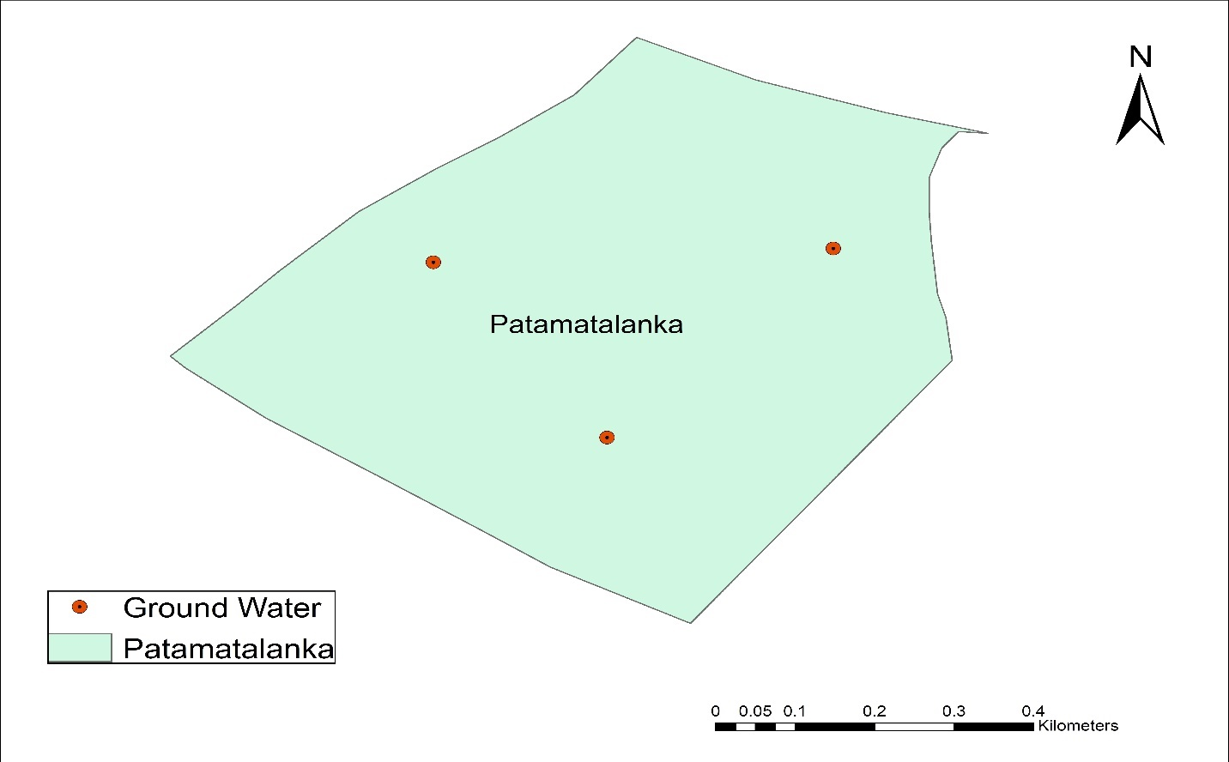

**Figure 4.10** Patamatalanka

|  |  |  |  |  |  |
| --- | --- | --- | --- | --- | --- |
| **TEST** | **UNITS** | **S1** | **S2** | **S3** | **Average** |
| **pH** | - | 7.1 | 7 | 7.5 | 7.2 |
| **TURBIDITY** | NTU | 1.2 | 1.1 | 1.1 | 1.1 |
| **TS** | mg/L | 931 | 954 | 1011 | 965 |
| **TSS** | mg/L | 6 | 20 | 20 | 15.3 |
| **TDS** | mg/L | 925 | 934 | 991 | 959 |
| **ALKALINITY** | mg/L CaCO3 | 501 | 511 | 586 | 532 |
| **CONDUCTIVITY** | µmhos/cm | 1423 | 1437 | 1525 | 1475.38 |
| **CHLORIDES** | mg/L | 171 | 189 | 245 | 201.41 |
| **TOTAL HARDNESS** | mg/L | 581 | 595 | 637 | 604 |
| **PERMANENT HARDNESS** | mg/L | 222 | 249 | 328 | 266 |
| **TEMPORARY HARDNESS** | mg/L | 359 | 346 | 309 | 338 |
| **Ca** | mg/L | 80.4 | 84.4 | 113.6 | 92.8 |
| **Mg** | mg/L | 82.86 | 87.72 | 100.60 | 60.39 |
| **SO4** | mg/L | 40 | 44 | 48 | 44 |

**Table 4.12** Test Results of Patamatalanka

**4.8.11 Location 11:** **Governorpet**

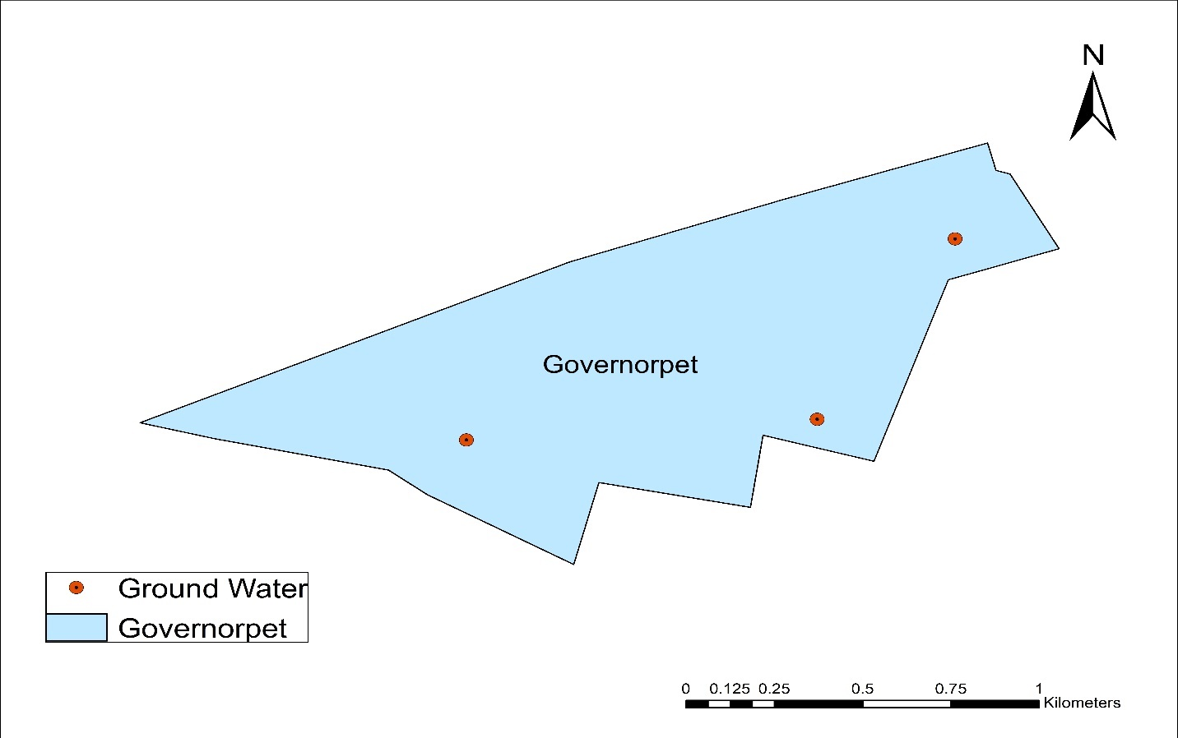

**Figure 4.11** Governorpet

|  |  |  |  |  |  |
| --- | --- | --- | --- | --- | --- |
| **TEST** | **UNITS** | **S1** | **S2** | **S3** | **Average** |
| **pH** | - | 7 | 7.35 | 7.7 | 7.35 |
| **TURBIDITY** | NTU | 1.2 | 1.1 | 1.1 | 1.1 |
| **TS** | mg/L | 832 | 856 | 881 | 856 |
| **TSS** | mg/L | 15 | 21 | 16 | 13 |
| **TDS** | mg/L | 817 | 835 | 865 | 843 |
| **ALKALINITY** | mg/L CaCO3 | 475 | 504 | 533 | 504 |
| **CONDUCTIVITY** | µmhos/cm | 1257 | 1285 | 1331 | 1296.92 |
| **CHLORIDES** | mg/L | 120 | 150 | 180 | 150.35 |
| **TOTAL HARDNESS** | mg/L | 472 | 500 | 528 | 501 |
| **PERMANENT HARDNESS** | mg/L | 101 | 138 | 175 | 138 |
| **TEMPORARY HARDNESS** | mg/L | 371 | 362 | 353 | 362 |
| **Ca** | mg/L | 85.2 | 99.2 | 114 | 99.2 |
| **Mg** | mg/L | 53.94 | 61.23 | 69.01 | 61.23 |
| **SO4** | mg/L | 22 | 26 | 30 | 26 |

**Table 4.13** Test Results of Governorpet

**4.8.12 Location 12:** **Enikepadu**

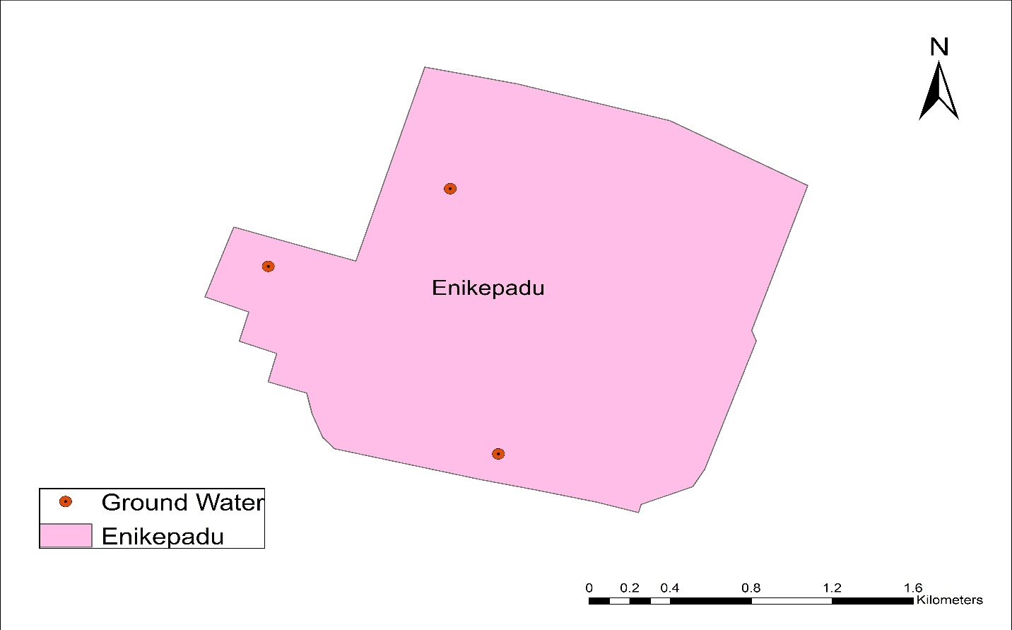

**Figure 4.12** Enikepadu

|  |  |  |  |  |  |
| --- | --- | --- | --- | --- | --- |
| **TEST** | **UNITS** | **S1** | **S2** | **S3** | **Average** |
| **pH** | - | 7 | 7.5 | 8.5 | 7.67 |
| **TURBIDITY** | NTU | 1.1 | 1.2 | 1.2 | 1.2 |
| **TS** | mg/L | 951 | 976 | 1048 | 991 |
| **TSS** | mg/L | 10 | 17 | 20 | 7 |
| **TDS** | mg/L | 941 | 959 | 1028 | 984 |
| **ALKALINITY** | mg/L CaCO3 | 321 | 341 | 396 | 352 |
| **CONDUCTIVITY** | µmhos/cm | 1448 | 1475 | 1582 | 1513.85 |
| **CHLORIDES** | mg/L | 549 | 565 | 620 | 578.35 |
| **TOTAL HARDNESS** | mg/L | 535 | 561 | 621 | 572 |
| **PERMANENT HARDNESS** | mg/L | 154 | 172 | 258 | 194 |
| **TEMPORARY HARDNESS** | mg/L | 381 | 389 | 363 | 378 |
| **Ca** | mg/L | 72.4 | 80.4 | 103.2 | 85.2 |
| **Mg** | mg/L | 78.03 | 82.62 | 101.57 | 87.23 |
| **SO4** | mg/L | 20 | 24 | 28 | 24 |

**Table 4.14** Test Results of Enikepadu

**4.8.13 Location 13: Kanuru**

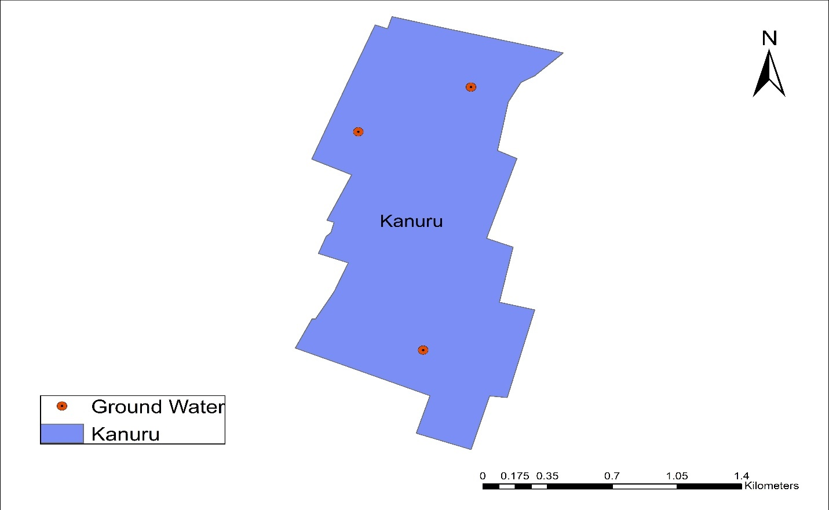

**Figure 4.13** Machavaram

|  |  |  |  |  |  |
| --- | --- | --- | --- | --- | --- |
| **TEST** | **UNITS** | **S1** | **S2** | **S3** | **Average** |
| **pH** | - | 6.5 | 7 | 8.3 | 7.25 |
| **TURBIDITY** | NTU | 1.1 | 1.1 | 1.1 | 1.1 |
| **TS** | mg/L | 741 | 761 | 848 | 783 |
| **TSS** | mg/L | 13 | 16 | 21 | 14 |
| **TDS** | mg/L | 728 | 745 | 827 | 769 |
| **ALKALINITY** | mg/L CaCO3 | 402 | 412 | 531 | 448 |
| **CONDUCTIVITY** | µmhos/cm | 1120 | 1146 | 1272 | 1183.08 |
| **CHLORIDES** | mg/L | 111 | 121 | 201 | 144.67 |
| **TOTAL HARDNESS** | mg/L | 335 | 362 | 467 | 388 |
| **PERMANENT HARDNESS** | mg/L | 146 | 165 | 231 | 180 |
| **TEMPORARY HARDNESS** | mg/L | 189 | 197 | 236 | 208 |
| **Ca** | mg/L | 80.4 | 85.2 | 113.2 | 92.8 |
| **Mg** | mg/L | 28.18 | 31.59 | 54.43 | 37.908 |
| **SO4** | mg/L | 44 | 48 | 52 | 48 |

**Table 4.15** Test Results of Gunadala

**4.8.14 Location 14: Ramavarappadu**

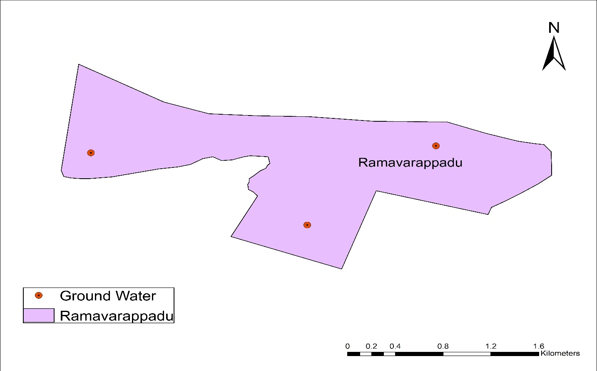

**Figure 4.14** Machavaram

|  |  |  |  |  |  |
| --- | --- | --- | --- | --- | --- |
| **TEST** | **UNITS** | **S1** | **S2** | **S3** | **Average** |
| **pH** | - | 7.5 | 7.75 | 8 | 7.75 |
| **TURBIDITY** | NTU | 1.1 | 1.2 | 1.2 | 1.2 |
| **TS** | mg/L | 620 | 659 | 698 | 659 |
| **TSS** | mg/L | 13 | 18 | 16 | 6 |
| **TDS** | mg/L | 607 | 641 | 682 | 653 |
| **ALKALINITY** | mg/L CaCO3 | 325 | 352 | 380 | 352 |
| **CONDUCTIVITY** | µmhos/cm | 934 | 986 | 1049 | 1004.62 |
| **CHLORIDES** | mg/L | 91 | 144 | 198 | 144.67 |
| **TOTAL HARDNESS** | mg/L | 301 | 332 | 363 | 332 |
| **PERMANENT HARDNESS** | mg/L | 102 | 154 | 206 | 154 |
| **TEMPORARY HARDNESS** | mg/L | 199 | 178 | 157 | 178 |
| **Ca** | mg/L | 52 | 72 | 92 | 72 |
| **Mg** | mg/L | 24.3 | 36.93 | 49.81 | 36.93 |
| **SO4** | mg/L | 60 | 64 | 68 | 64 |

**Table 4.16** Test Results of Gunadala

**4.8.15 Location 15:** **Gollapudi**

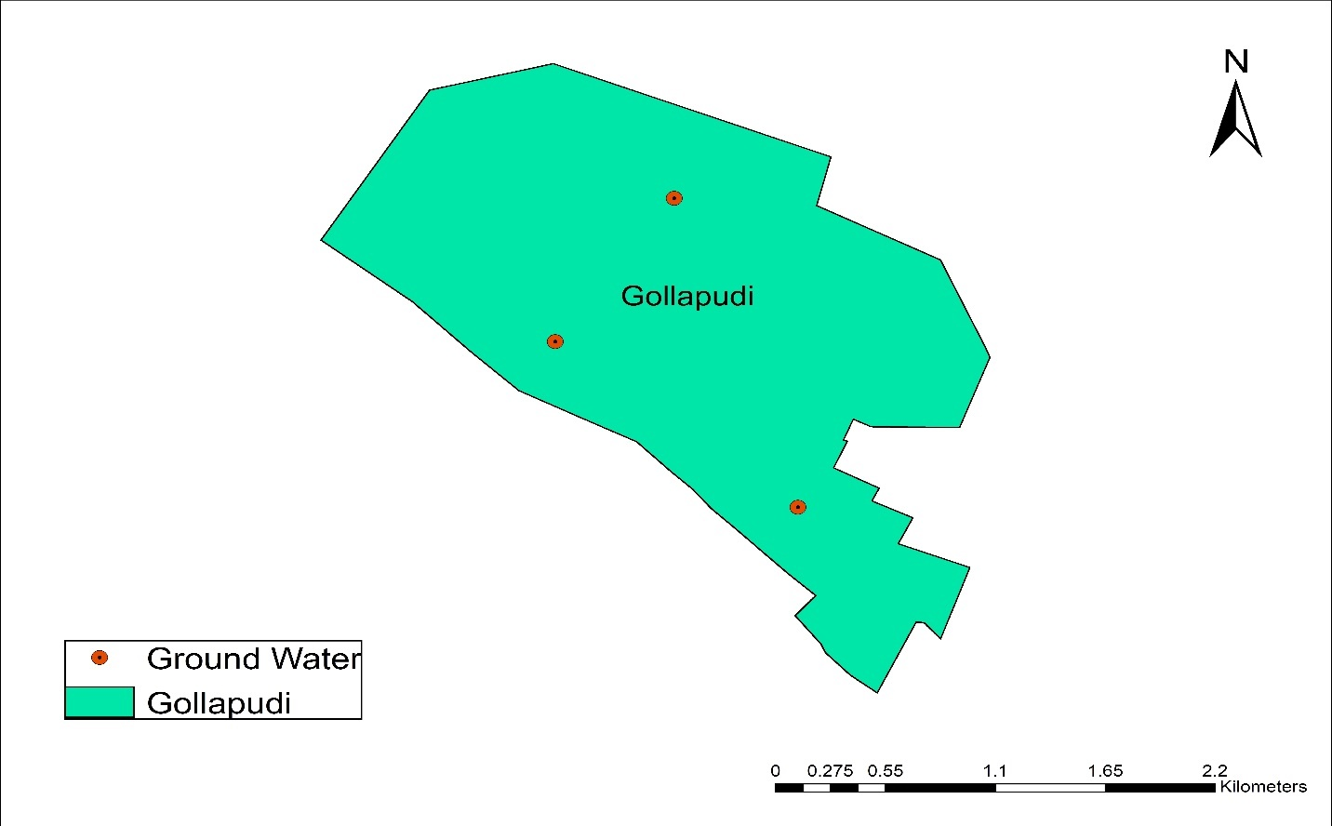

**Figure 4.15** Gollapudi

|  |  |  |  |  |  |
| --- | --- | --- | --- | --- | --- |
| **TEST** | **UNITS** | **S1** | **S2** | **S3** | **Average** |
| **pH** | - | 7 | 7.5 | 7.75 | 7.45 |
| **TURBIDITY** | NTU | 1.2 | 1.3 | 1.4 | 1.4 |
| **TS** | mg/L | 1203 | 1313 | 1369 | 1295 |
| **TSS** | mg/L | 8 | 14 | 15 | 16 |
| **TDS** | mg/L | 1195 | 1299 | 1354 | 1279 |
| **ALKALINITY** | mg/L CaCO3 | 529 | 596 | 616 | 580 |
| **CONDUCTIVITY** | µmhos/cm | 1838 | 1998 | 2083 | 1967.69 |
| **CHLORIDES** | mg/L | 312 | 381 | 371 | 354.6 |
| **TOTAL HARDNESS** | mg/L | 632 | 712 | 734 | 692 |
| **PERMANENT HARDNESS** | mg/L | 201 | 271 | 302 | 258 |
| **TEMPORARY HARDNESS** | mg/L | 431 | 441 | 432 | 434 |
| **Ca** | mg/L | 90.4 | 120.4 | 135.6 | 115.2 |
| **Mg** | mg/L | 91.36 | 104.73 | 98.65 | 98.17 |
| **SO4** | mg/L | 68 | 72 | 76 | 72 |

**Table 4.17** Test Results of Gollapudi

**4.8.16 Location 16: Ayodhya Nagar**

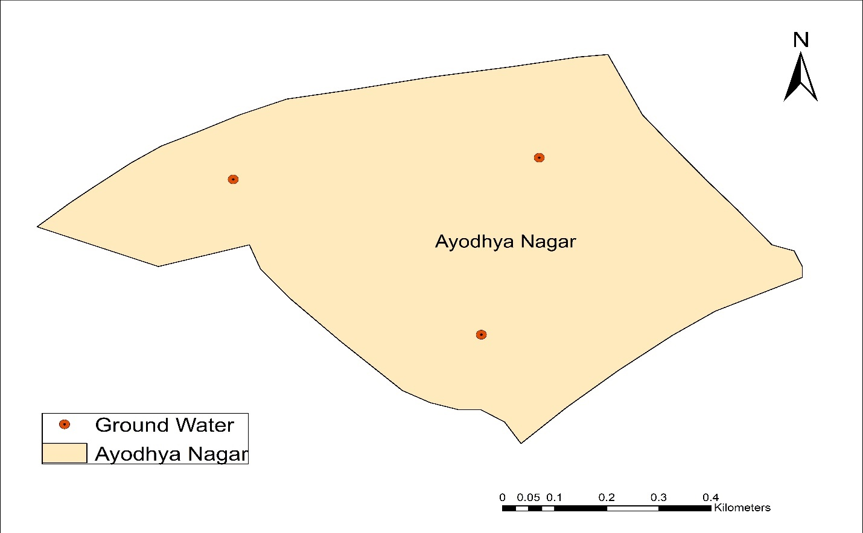

**Figure 4.16** Ayodhya Nagar

|  |  |  |  |  |  |
| --- | --- | --- | --- | --- | --- |
| **TEST** | **UNITS** | **S1** | **S2** | **S3** | **Average** |
| **pH** | - | 7 | 7.4 | 7.75 | 7.37 |
| **TURBIDITY** | NTU | 1.8 | 1.9 | 1.9 | 1.9 |
| **TS** | mg/L | 1301 | 1401 | 1466 | 1389 |
| **TSS** | mg/L | 10 | 12 | 17 | 13 |
| **TDS** | mg/L | 1291 | 1389 | 1449 | 367 |
| **ALKALINITY** | mg/L CaCO3 | 625 | 665 | 668 | 652 |
| **CONDUCTIVITY** | µmhos/cm | 1986 | 2137 | 2229 | 2124.54 |
| **CHLORIDES** | mg/L | 391 | 420 | 431 | 414.17 |
| **TOTAL HARDNESS** | mg/L | 191 | 225 | 232 | 216 |
| **PERMANENT HARDNESS** | mg/L | 67 | 126 | 137 | 110 |
| **TEMPORARY HARDNESS** | mg/L | 124 | 99 | 95 | 106 |
| **Ca** | mg/L | 35.6 | 52.4 | 31.6 | 49.6 |
| **Mg** | mg/L | 10.93 | 27.21 | 29.16 | 22.35 |
| **SO4** | mg/L | 102 | 106 | 110 | 106 |

**Table 4.18** Test Results of Ayodhya Nagar

**4.9 Thematic Maps showing Spatial Distribution of Sample Analysis:**

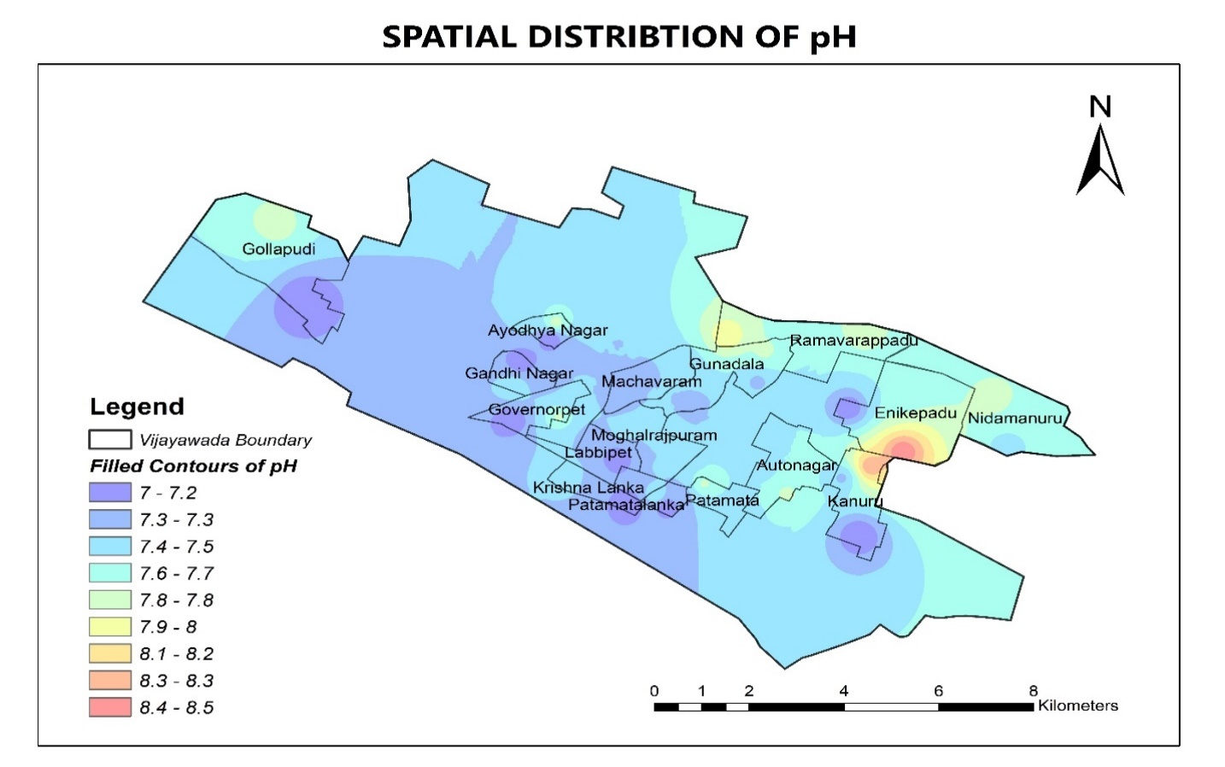

**Figure 4.17** Spatial Distribution of pH

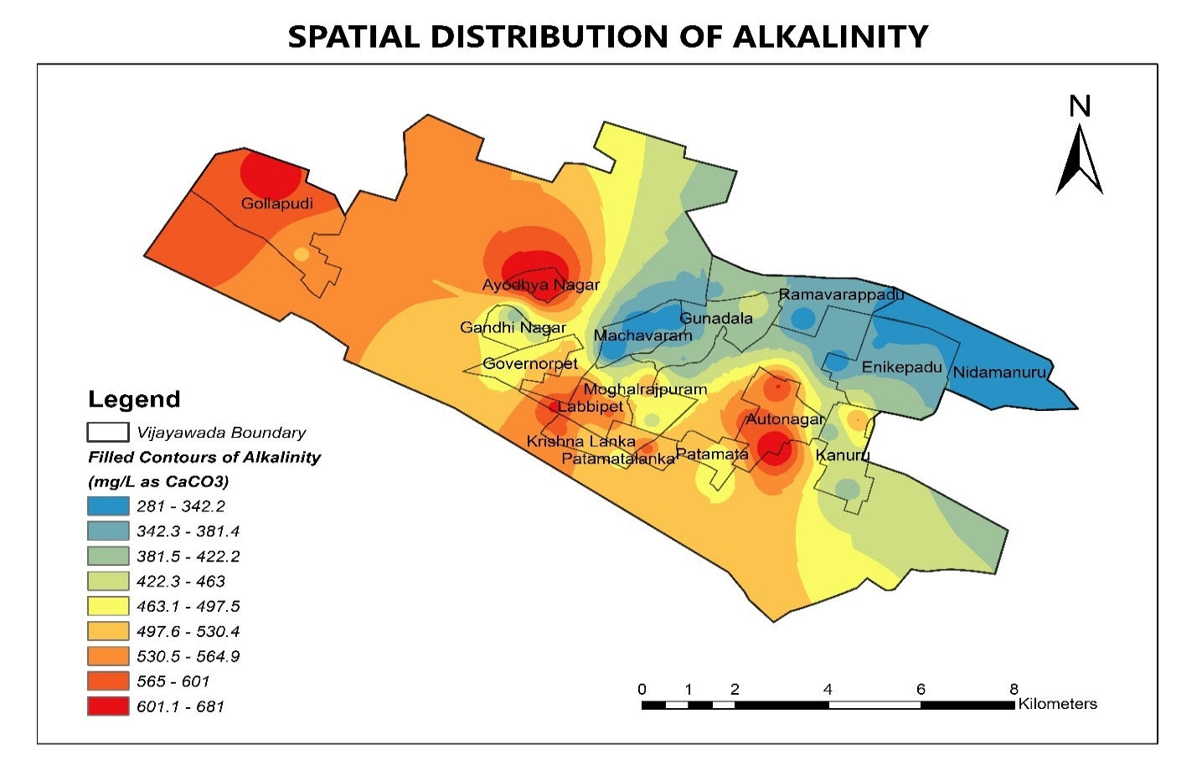

**Figure 4.18** Spatial Distribution of Alkalinity

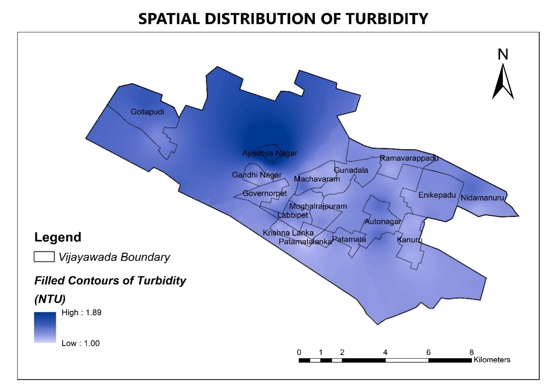

**Figure 4.19** Spatial Distribution of Turbidity

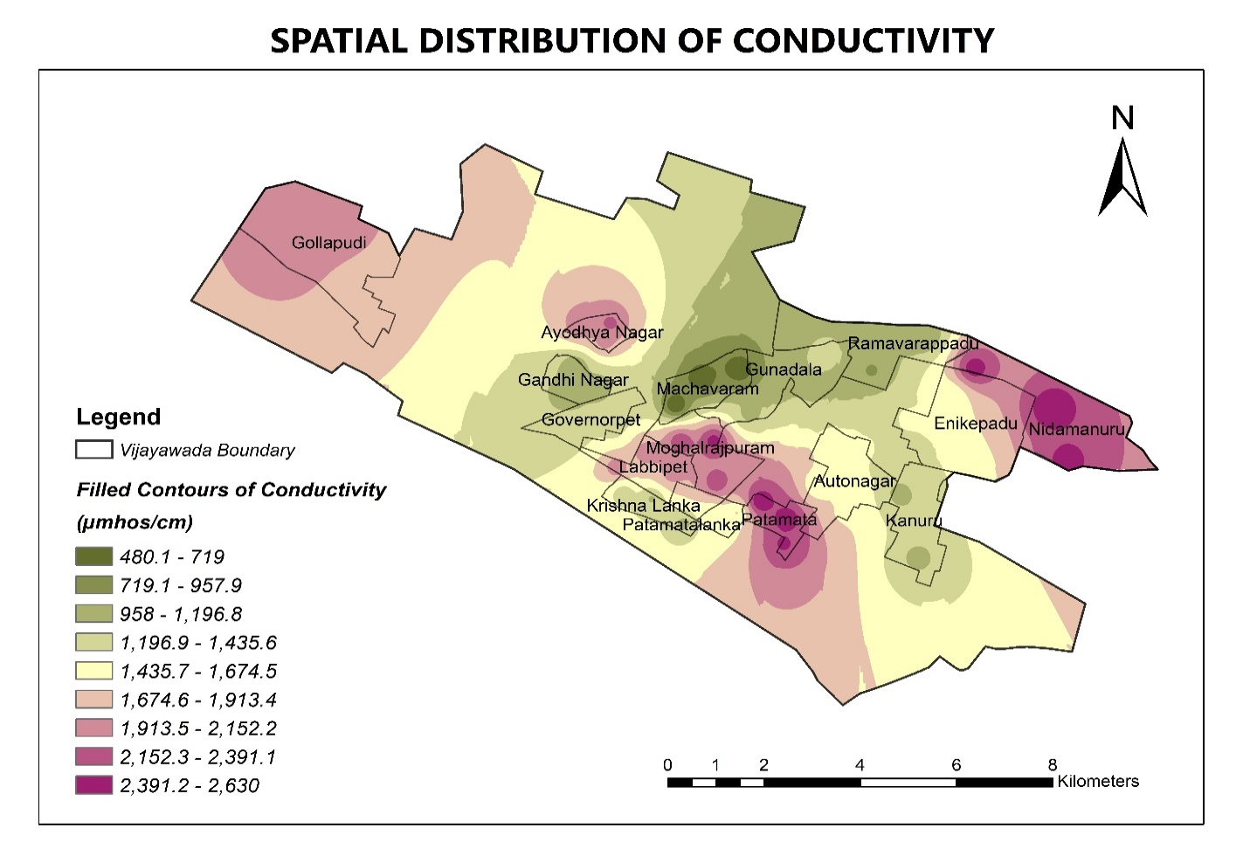 **Figure 4.20** Spatial Distribution of Conductivity

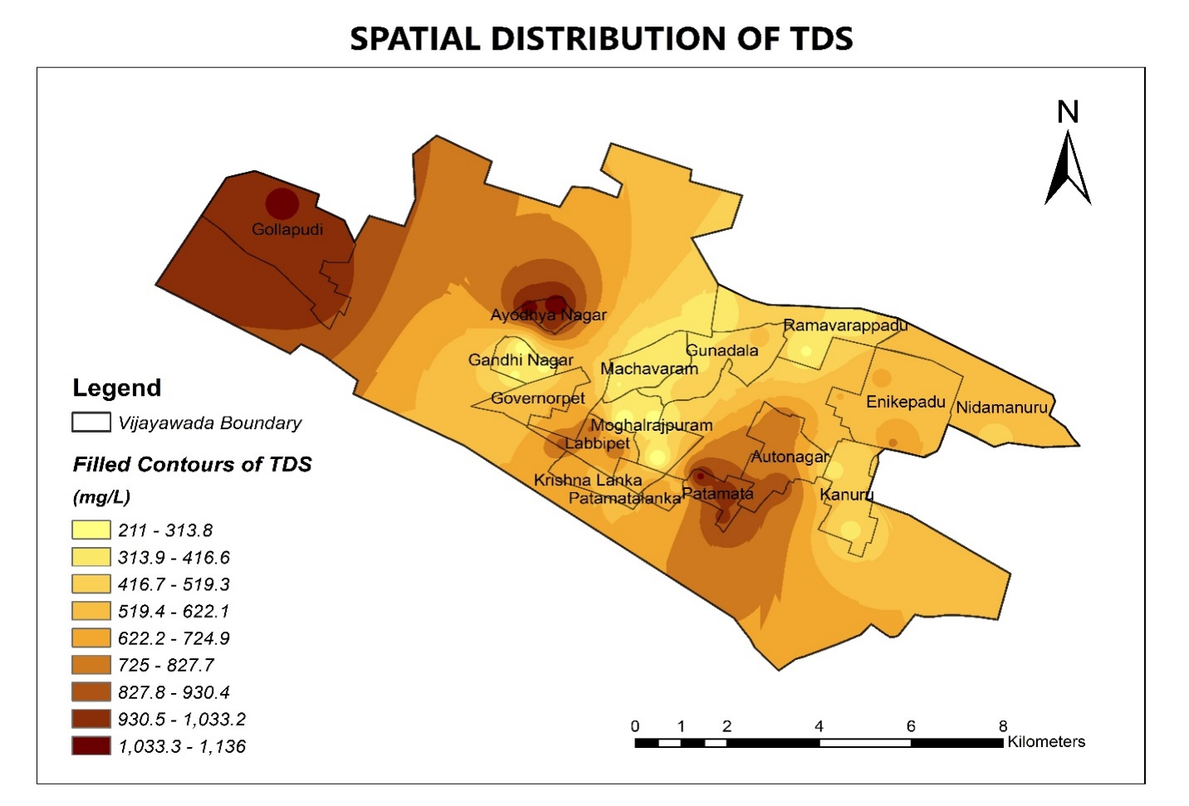**Figure 4.21** Spatial Distribution of TDS

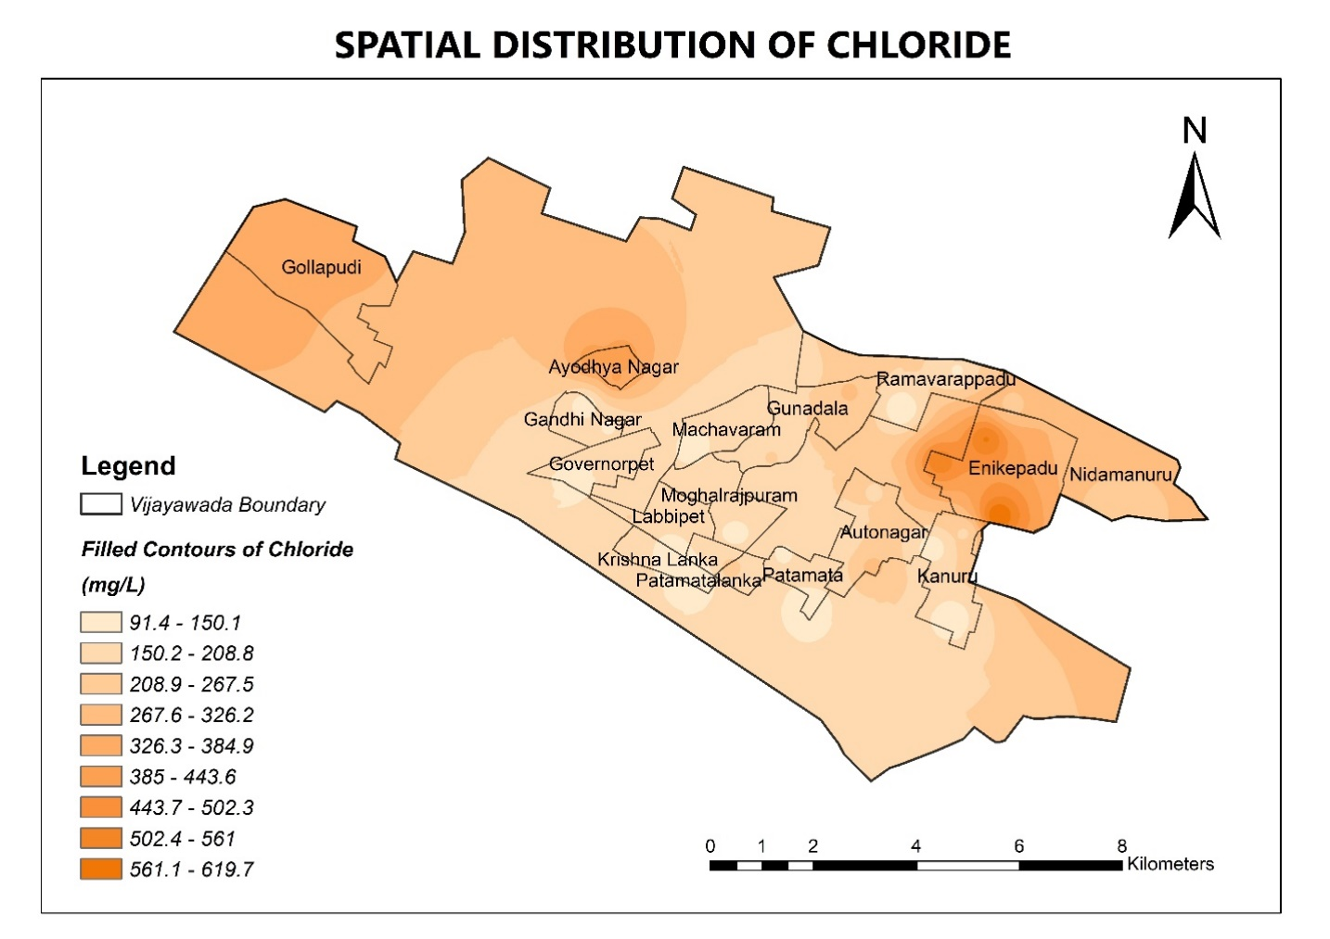

**Figure 4.22** Spatial Distribution of Chloride

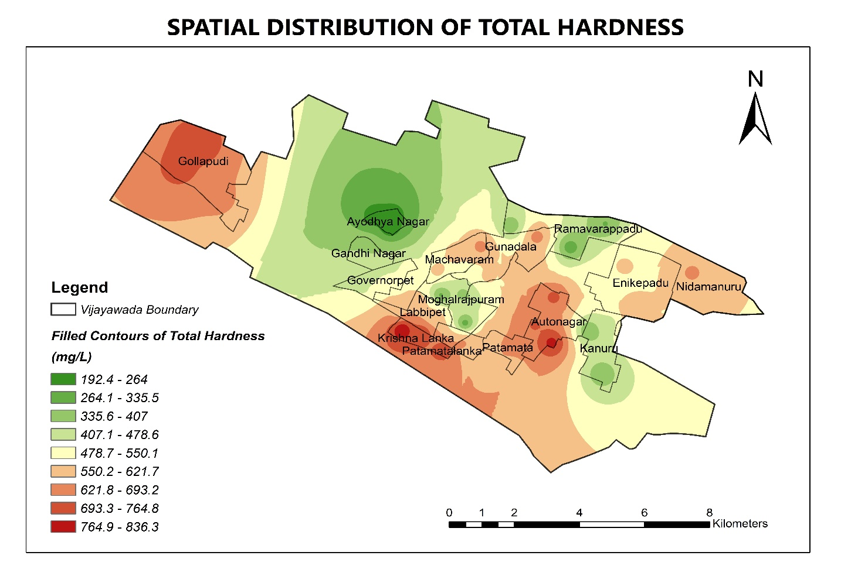

**Figure 4.23** Spatial Distribution of Total Hardness

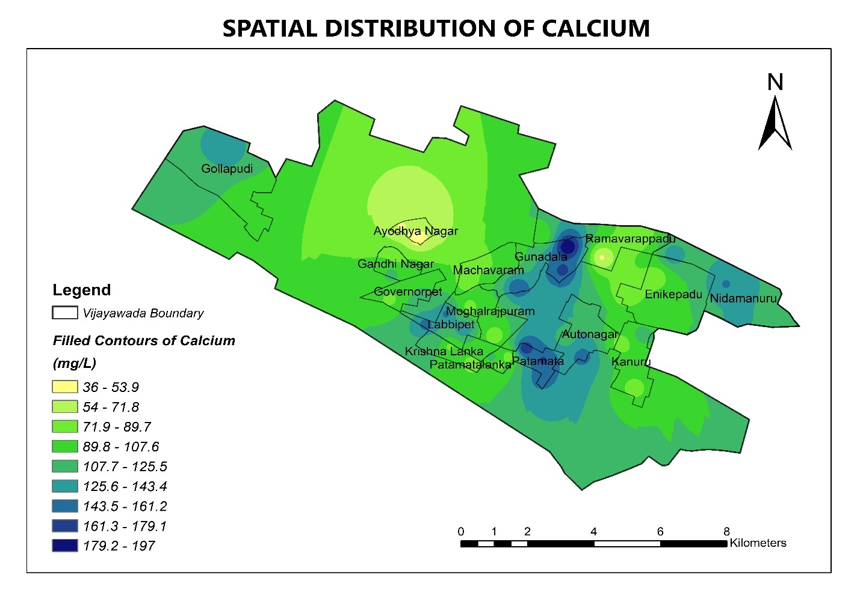

**Figure 4.24** Spatial Distribution of Calcium

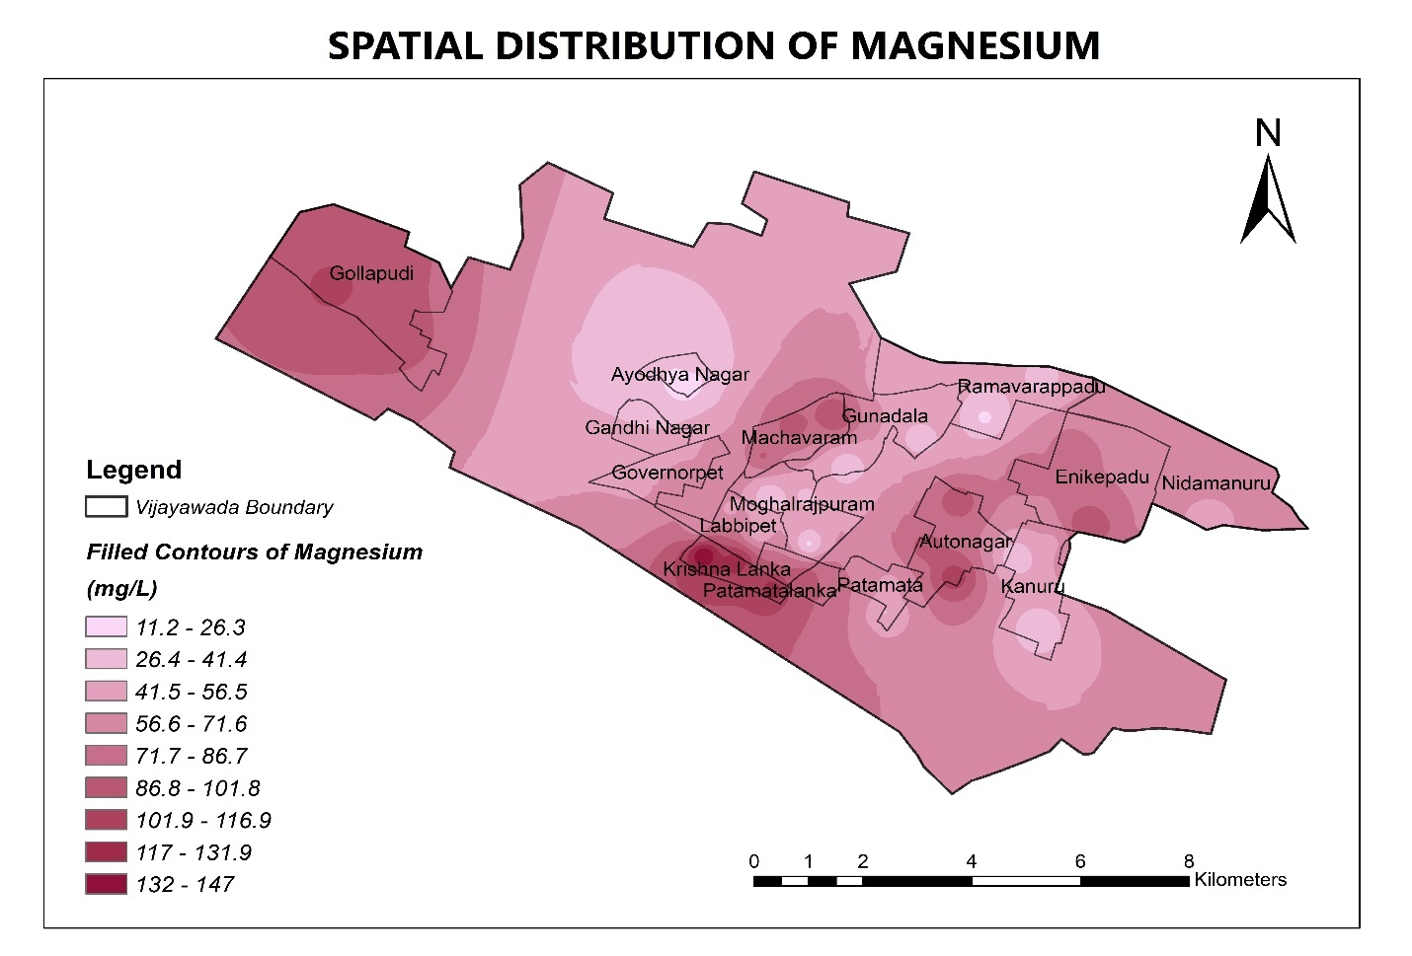

**Figure 4.25** Spatial Distribution of Magnesium

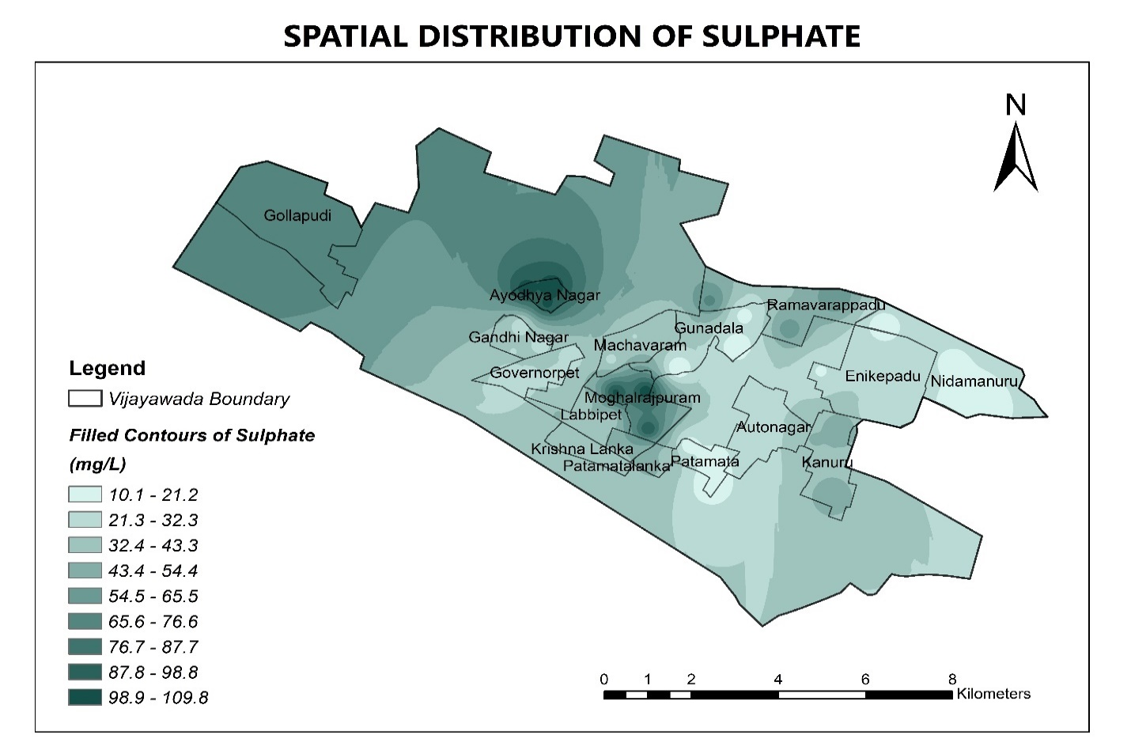

**Figure 4.26** Spatial Distribution of Sulphate

**CHAPTER 5**

**RESULT AND DISCUSSION**

**CHAPTER 5**

**RESULT AND DISCUSSION**

**WATER QUALITY PARAMETERS AND STANDARDS FOR VARIOUS PHYSICAL AND CHEMICAL CONSTITUENTS:**

|  |  |  |  |
| --- | --- | --- | --- |
| **S.No.** | **Parameters** | **IS 10500: 2012, IS 3025(Part 40), WHO** | |
| **Permissible Limit** | **Maximum Limit** |
| 1 | Colour | Agreeable | Agreeable |
| 2 | Odour | Agreeable | Agreeable |
| 3 | Taste | Agreeable | Agreeable |
| 4 | pH | 6.5 to 8.5 | No relaxation |
| 5 | Turbidity (NTU) | 1 | 5 |
| 6 | Alkalinity (as CaCO3) (mg/L) | 200 | 600 |
| 7 | Electrical Conductivity  (μmhos/cm) | 500 | 1500 |
| 8 | TDS (mg/L) | 500 | 2000 |
| 9 | Chloride (mg/L) | 250 | 1000 |
| 10 | Hardness (as CaCO3) (mg/L) | 200 | 600 |
| 11 | Calcium (as Ca) mg/L | 250 | 1000 |
| 12 | Magnesium (as Mg) mg/L | 30 | 100 |
| 13 | Sulphate (mg/L) | 200 | 400 |

**Table 5.1** Water Quality Standards

**EVALUATION OF WATER QUALITY PARAMETERS WITH PERMISSIBLE LIMITS:**

|  |  |  |  |  |  |  |  |  |  |  |  |
| --- | --- | --- | --- | --- | --- | --- | --- | --- | --- | --- | --- |
| S.No. | Locations | Physico - Chemical Parameters | | | | | | | | | |
| pH | Turbidity | Alkalinity | EC | TDS | Cl | Hardness | Ca | Mg | SO4 |
| 1 | Patamata | ✔ | ❌ | ❌ | ❌ | ❌ | ✔ | ❌ | ✔ | ❌ | ✔ |
| 2 | Gandhi Nagar | ✔ | ❌ | ❌ | ❌ | ❌ | ✔ | ❌ | ✔ | ❌ | ✔ |
| 3 | Machavaram | ✔ | ❌ | ❌ | ❌ | ✔ | ✔ | ❌ | ✔ | ❌ | ✔ |
| 4 | Nidamanuru | ✔ | ❌ | ❌ | ❌ | ❌ | ✔ | ❌ | ✔ | ❌ | ✔ |
| 5 | Labbipet | ✔ | ❌ | ❌ | ❌ | ❌ | ✔ | ❌ | ✔ | ❌ | ✔ |
| 6 | Moghalrajpuram | ✔ | ❌ | ❌ | ❌ | ✔ | ✔ | ❌ | ✔ | ✔ | ✔ |
| 7 | Gundala | ✔ | ❌ | ❌ | ❌ | ❌ | ✔ | ❌ | ✔ | ❌ | ✔ |
| 8 | Krishna Lanka | ✔ | ❌ | ❌ | ❌ | ❌ | ✔ | ❌ | ✔ | ❌ | ✔ |
| 9 | Auto Nagar | ✔ | ❌ | ❌ | ❌ | ❌ | ✔ | ❌ | ✔ | ❌ | ✔ |
| 10 | Patamatalanka | ✔ | ❌ | ❌ | ❌ | ❌ | ✔ | ❌ | ✔ | ❌ | ✔ |
| 11 | Governorpet | ✔ | ❌ | ❌ | ❌ | ❌ | ✔ | ❌ | ✔ | ❌ | ✔ |
| 12 | Enikepadu | ✔ | ❌ | ❌ | ❌ | ❌ | ❌ | ❌ | ✔ | ❌ | ✔ |
| 13 | Kanuru | ✔ | ❌ | ❌ | ❌ | ❌ | ✔ | ❌ | ✔ | ❌ | ✔ |
| 14 | Ramavarappadu | ✔ | ❌ | ❌ | ❌ | ❌ | ✔ | ❌ | ✔ | ❌ | ✔ |
| 15 | Gollapudi | ✔ | ❌ | ❌ | ❌ | ❌ | ❌ | ❌ | ✔ | ✔ | ✔ |
| 16 | Ayodhya Nagar | ✔ | ❌ | ❌ | ❌ | ❌ | ❌ | ❌ | ✔ | ❌ | ✔ |

|  |  |  |
| --- | --- | --- |
| ✔ | : | Within the permissible limits. |
| ❌ | : | Outside the permissible limits. |

**Table 5.2** Evaluated Water Quality Parameters at different locations

## 5.1 INSIGHT:

## 5.1.1 pH

Measurement of PH Value In the study area of 16 water locations, Ph value is in the limits. All the measured pH values are given in the Tables of each location and the spatial distribution map is shown in the Figures which indicates that the eastern and western portions of the basin is more alkaline compared to central portion of the basin.

## 5.1.2 Turbidity

Measurement of Turbidity Value In the study area of 16 water locations, Turbidity value is not in the limits. All the measured Turbidity values are given in the Tables of each location and the spatial distribution map is shown in the Figures which indicates that the northern portions of the basin is more Turbidity compared `to southern portion of the basin.

## 5.1.3 Alkalinity

Measurement of Alkalinity Value In the study area of 16 water locations, Alkalinity value is not in the limits. All the measured Alkalinity values are given in the Tables of each location and the spatial distribution map is shown in the Figures which indicates that the eastern portions of the basin is more Alkalinity compared `to western portions of the basin.

## 5.1.4 Conductivity

More or less following the TDS way i.e., the eastern and western portions of the basins is having higher conductivity as it is having more dissolved salts compared to the northern portion of the basin. According to the map (Fig.12) the central portion of the basin is having high values of EC, whereas the North part of the basin are showing low EC values.

## 5.1.5 TDS

Maximum TDS concentration of 500 mg/l is allowed for drinking water, in all locations the TDS is not in the limits except in the sample no 3 and 6 in which it is in the limits. The highest value is 1555. In the study area the TDS value of the drinking water locations 3 and 6 is within the desirable limits. All the values of the TDS are tabulated in the Table and the spatial distribution map of the TDS indicates the same trend as the EC map.

## 5.1.6 Chloride

In the entire water locations, the Chloride concentration is within the desirable limits, and it ranges from 90 – 200 mg/l with an average value 144.67 mg/l and the values are tabulated in the Table the spatial distribution map is shown in Fig and it indicates that the western portion of the basin is having somewhat higher values of Chloride, but within the desirable limits only. In the drinking water locations (12, 15, 16) the Chloride concentrations are 578.35 mg/l and 354.56 mg/l and 414.17 mg/l respectively.

## 5.1.7 Calcium

In the study area all sample contains the calcium with in the desirable drinking water standards.

## 5.1.8 Magnesium

The magnesium concentration ranges from 30.132 – 98.17 mg/l, in drinking water locations (6, 15). It is with in the desirable limits. The concentrations of Ca+2, are given in the Table and the spatial maps are shown in Fig.

## 5.10 Sulphate

In all the water locations the Sulphate concentration is within the desirable limits, and it ranges from 98 – 102 mg/l and the values are tabulated in the Table, the spatial distribution map is also shown in Fig. which indicates that South – East and North – East corners of the basin are having somewhat higher values but all the values are within the desirable limit.

**5.2 EFFECTS AND REMEDIES OF UNSAFE PARAMETERS:**

**pH**

EFFECTS of pH:

* Drinking water with an elevated pH above 11 can cause skin, eye and mucous membrane irritation.
* On the opposite end of the scale, pH values below 4 also cause irritation due to the corrosive effects of low pH levels.
* At low pH values generally have few negative health effects. Acidic drinking water can cause serious problems, through the leaching of heavy metals from plumbing systems.
* Aquatic wildlife also suffers from the effects of pH extremes. Fish die- off occurs when pH levels dip below 4.5 or rise above 10.

TREATMENT FOR pH IN DRINKING WATER:

* Two home treatment methods to adjust pH are acid neutralizing filters and chemical feed pump systems injecting a neutralizing solution. An acid neutralizing filter uses a calcite or ground limestone (calcium carbonate) for normal pH correction, but could also include a blend of magnesium oxide and calcite, if the pH is very low.

**ALKALINITY**

EFFECTS OF ALKALINITY IN WATER:

* Effect on pH Levels. Alkaline water has no effect upon the pH levels of the physical body; After ingestion, alkaline...
* Cardiovascular Disease. Drinking alkaline water causes chemical changes within the body that affect the health and...
* Digestion. Proper digestion relies on the presence of hydrochloric acid in the stomach to chemically break down food and...

TREATMENT OF ALKALINITY:

* + - * Reverse Osmosis – Membrane filtration has become the popular option for boiler water treatment. With appropriate...
      * Chloride Anion Dealkalizers – Chloride anion dealkalizers operate similar to ion exchange water softeners, except the...
      * Weak Acid Dealkalization – When the ratio of water hardness to alkalinity is 1 or greater, a weak acid cation (WAC)...

**TURBIDITY**

EFFECTS OF TURBIDITY IN WATER:

* + - * Turbidity affects the growth rate of algae (micro-aquatic plants) and other aquatic plants in streams and lakes because increased turbidity causes a decrease in the amount of light for photosynthesis.
      * Turbidity can alsoincrease water temperature because suspended particles absorb more heat. These factors lead to a decrease in dissolved oxygen.

TREATMENT OF TURBIDITY:

* + - * Cloth Filtration. A simple option to pre-treat turbid water is to filter through a locally available cloth
      * Sand Filtration. Filtration through clean sand is a fast and simple pre-treatment option.

**TOTAL SOLIDS**

EFFECTS:

* High concentrations of solids can cause many problems for stream health and aquatic life.
* High TS can block light from reaching submerged vegetation and as a result photosynthesis slows down.
* High TS can also cause an increase in surface water temperature, because the suspended particles absorb heat from sunlight. This can cause dissolved oxygen levels to fall even further and can harm aquatic life.

TREATMENT FOR TS

* + Gravity settling

Solid particles, because of their heavier density (compared to water) and net negative buoyant force, will settle to the bottom with a terminal velocity. After settle solids water is removed.

* + Filtration

Small-diameter suspended particles by filtration process.

**TOTAL DISSOLVED SOLIDS**

EFFECTS OF TDS:

* At higher levels, excessive hardness, unpalatability, mineral deposition and corrosion may occur.
* At low levels, however, TDS contributes to the palatability of water.
* High TDS levels (>500 mg/litre) result in excessive scaling in water pipes, water heaters, boilers, and household appliances such as kettles and steam irons.
* High concentrations of TDS may also reduce water clarity, contribute to a decrease in photosynthesis, combine with toxic compounds and heavy metals, and lead to an increase in water temperature.

TREATMENT FOR TDS:

* Treatment for TDS content depends upon which compounds make up the dissolved solids content of an individual’s water supply.
* Excess calcium and magnesium as well as small amounts of iron can usually be removed through traditional salt-based softeners. While the overall TDS content will not be reduced, by replacing these minerals with sodium, impact of hard water will be mitigated.
* For other compounds like sulphates nitrates and sodium, a reverse osmosis or distillation system is usually needed.
* If there is high TDS content, the water treatment system is used.

**CHLORIDES**

EFFECTS OF CHLORIDES IN WATER:

* + - * Although chlorides are harmless at low levels, well water high in sodium chloride can damage plants if used for gardening or irrigation, and give drinking water an unpleasant taste.
      * Over time, sodium chloride’s high corrosivity will also damage plumbing, appliances, and water heaters, causing toxic metals to leach into your water.
      * At levels greater than this, sodium chloride can complicate existing heart problems and contribute to high blood pressure when ingested in excess.

TREATMENT OF CHLORIDES:

* + - * Reverse Osmosis will remove 90 - 95% of the chlorides because of its salt rejection capabilities.
      * Electro dialysis and distillation are two more processes that can be used to reduce the chloride content of water.

**HARDNESS OF WATER**

EFFECTS

* The health effects of hard water are mainly due to the effects of the salts dissolved in it, primarily calcium and magnesium. To a large extent, individuals are protected from excess intakes of calcium by a tightly regulated intestinal absorption mechanism through the action of 1, 25- dihydroxy-vitamin D, the hormonally active form of vitamin D.
* Increased soap usage in hard water results in metal or soap salt residues on the skin or on clothes that are not easily rinsed off and that lead to contact irritation.

TREATMENT FOR HARDNESS

* Chemical Process of Boiling Hard Water

http://images.tutorvista.com/contentimages/chemistry_11/content/us/class11chemistry/chapter11/images/img181.gifWe can boil water to remove temporary hardness. Temporary hardness in water can be easily removed by boiling. On boiling, calcium/magnesium bicarbonate decomposes to give calcium/magnesium carbonate, which is insoluble in water. Therefore, it precipitates out.

* Ion Exchange Process (Permutit Process)

Permutit or zeolites are packed in a suitable container and a slow stream of hard water is passed through this material. As a result, calcium and magnesium ions present in hard water are exchanged with sodium ions in the Permutit (Na+Al-Silicate). The outgoing water contains sodium salts, which do not cause hardness.

**CALCIUM**

EFFECTS OF CALCIUM IN WATER:

* + - * Calcium is largely responsible for water hardness, and may negatively influence toxicity of other compounds
      * Elements such as copper, lead and zinc are much more toxic in soft water. In limed soils calcium may immobilize iron. This may cause iron shortages, even when plenty of iron is present in the soil.

TREATMENT OF CALCIUM:

* + - * Reverse Osmosis. You have probably heard about the Reverse Osmosis water purifying system.
      * Boiling

MAGNESIUM:

EFFECTS OF MAGNESIUM IN WATER:

* + - * Drinking-water in which both magnesium and sulphate are present in high concentrations (~250 mg/l each) can have a laxative effect.
      * Laxative effects have also been associated with excess intake of magnesium taken in the form of supplements, but not with magnesium in the diet.

TREATMENT OF MAGNESIUM:

* + - * Reverse Osmosis. You have probably heard about the Reverse Osmosis water purifying system.
      * Ion exchange Water Softener

**SULPHATE**

EFFECTS OF SULPHATE IN WATER:

* + - * People who are not used to drinking water with high sulphate can get diarrhoea and dehydration from drinking the water.
      * Infants are often more sensitive to sulphate than adults.

TREATMENT OF SULPHATE:

* + - * Adsorption: Adsorption is the process of capturing contaminants from a liquid stream by using molecular forces.
      * Distillation: Distillation involves heating sulphate-saturated liquids to boiling, then cooling the resulting water.

**CONCLUSION**

* + The present study of ground water in Patamata, Gandhi Nagar, Machavaram, Nidamanuru, Labbipet, Moghalrajpuram, Gundala, KrishnaLanka, AutoNagar, Patamatalanka, Governorpet, Enikepadu, Kanuru, Ramavarappadu, Gollapudi, Ayodhya Nagar with a comprehensive of the parameters is studied.
  + The spatial distribution maps of Turbidity, Alkalinity, TDS, Conductivity, Hardness, Magnesium shows that these parameters are not in the permissible limit in the study area.
  + This study has shown that the use of GIS is very useful tool for the assessment of ground water quality.
  + Finally, it is concluded by using GIS technology has great potential to revolutionize ground water monitoring and management in the future. Rapidly expanding GIS technology will play a central role in handling the voluminous spatio-temporal data and their effective interpretation, analysis and presentation, through GIS applications.
  + It is recommended that groundwater should be treated prior to use as drinking water by using reverse osmosis for large scale and filters for small scale needs. Also ground water recharge with rainwater improves the quality of ground water by balancing various physiochemical properties.
  + Effects and Remedies for various unsafe parameters have been identified.
  + Web Sites:

[www.google.com](http://www.google.com/) [www.googleearth.com](http://www.googleearth.com/)

[www.gisdevelopment.net](http://www.gisdevelopment.net/)

[www.mapsofindia.com](http://www.mapsofindia.com/)

[http://ga.water.usgs.gov](http://ga.water.usgs.gov/)

**REFERENCES**

* 1. Abbulu, Y., and G.V.R. Srinivasa Rao (2013), “A Study on Physico - Chemical Characteristics of Groundwater in the Industrial Zone of Visakhapatnam, Andhra Pradesh”, American Journal of Engineering Research, Vol. 2, Issue-10, pp-112-116.
  2. Akhilesh J., and D. Savita (2008), “Pre and Post - Monsoon Variation in Physico - Chemical Characteristics in Groundwater Quality of Bhopal "The City of Lakes" India”, Asian J. Exp. Sci., Vol. 22, No. 3, pp: 311-316.
  3. Asit K. B., and C. Surajit (2015), “Hydrogeochemistry and Water Quality Index in the assessment of Groundwater Quality for Drinking Uses”, Water Environmental Research, Volume 87, Number 7.
  4. IS 10500 (2012), “Drinking Water – Specification”
  5. IS 3025 (1984), “Methods of Sampling and Test (Physical and Chemical) for Water and Waste Water”.
  6. “Guidelines for Drinking-water Quality” - Fourth Edition World Health Organizaition.
  7. Leelavathi, Ch., Krishna Sainath, U., and A. K. Rabbani, (2016), “Physicochemical Characterization of ground water of Autonagar, Vijayawada, Krishna district”, Int. Journal of Engineering Development and Research , Vol-4 (2), pp-1324-1328.
  8. Sirajudeen, J., M. K. Mohidheen and, R. A. Vahith (2014) “Physico-chemical contamination of groundwater in and around Tirunelveli district, Tamil Nadu”, Advances in Applied Science Research, 2014, 5(2),pp: 49-54.
  9. Hanumantharao Chappidi, Mallela Koteswara Rao, Thathapudi Kalyan “Groundwater Quality Assessment for Drinking Purpose in Vijayawada Region, Andhra Pradesh, India”
  10. B. Thanga Gurusamy “Spatial distribution analysis and mapping of ground water quality across Chennai”.